

**SWP391 PROJECT REPORT**

**Software User Guides**

– Da Nang, July 2023 –

Table of Contents

I. Record of Changes 4

II. Release Package & User Guides 4

1. Deliverable Package 4

2. Installation Guides 5

2.1 System Requirements 5

2.2 Installation Instruction 5

3. User Manual 5

3.1 Overview 5

3.2 User Manual Guide for Guest 6

3.3 User Manual Guide for User 10

3.4 User Manual Guide for Admin 25

Table of Tables

Table 1. Deliverable Package ..................................................................................................................... 5

Table 2. Software requirement .................................................................................................................. 5

Table of Figures

Figure 1. Step 2 in View Homepage 6

Figure 2. Step 2 in Sign up with Fdorm Account 6

Figure 3. Step 4 in Sign up with Form Account. 7

Figure 4. Step 5 in Sign up with Fdorm Account 7

Figure 5. Step 2 in View notifications in Homepage 8

Figure 6. Step 2 in View a Course’s Overview 9

Figure 7. Step 3 in send contact information to the dormitory 9

Figure 8. Step 4 in send contact information to the dormitory 10

Figure 9. Step 2 in Sign In 10

Figure 10. Step 3 in Sign In 11

Figure 11. Step 2 in Sign Out 12

Figure 12. Step 2 in Change password 12

Figure 13. Step 5 in Change password 13

Figure 14. Step 7 in Change password 13

Figure 15. Step 2 in search room 14

Figure 16. Step 4 in search room 14

Figure 17. Step 2 in book a room 15

Figure 18. Step 4 in book a room 15

Figure 19. Step 5 in book a room 16

Figure 20. Step 2 in room payment 16

Figure 21. Step 3 in room payment 17

Figure 22. Step 2 in electricity and water payment 17

Figure 23. Step 3 in electricity and water payment 18

Figure 24. Step 2 in send request to change room 18

Figure 25. Step 3 in send request to change room 19

Figure 26. Step 4 in send request to change room 19

Figure 27. Step 5 in send request to change room 20

Figure 28. Step 2 in send request to maintenance, complaints 20

Figure 29. Step 3 in send request to maintenance, complaints 21

Figure 30. Step 4 in send request to maintenance, complaints 21

Figure 31. Step 5 in send request to maintenance, complaints 22

Figure 32. Step 2 in view room registration history 22

Figure 33. Step 3 in view room registration history 23

Figure 34. Step 2 in update profile 23

Figure 35. Step 3 in update profile 24

Figure 36. Step 4 in update profile 24

Figure 37. Step 2 in view notifications 25

Figure 38. Step 3 in view notifications 25

Figure 39. Step 2 in create notification 26

Figure 40. Step 3 in create notification 26

Figure 41. Step 4 in create notification 27

Figure 42. Step 2 in update notification 27

Figure 43. Step 3 in update notification 28

Figure 44. Step 4 in update notification 28

Figure 45. Step 2 in delete notification 29

Figure 46. Step 2 in view student information. 29

Figure 47. Step 3 in view student information. 30

Figure 48. Step 2 in update student information 30

Figure 49. Step 3 in update student information 31

Figure 50. Step 4 in update student information 31

Figure 51. Step 2 in view room 32

Figure 52. Step 3 in view room 32

Figure 53. Step 2 in create room 33

Figure 54. Step 3 in create room 33

Figure 55. Step 4 in create room 34

Figure 56. Step 2 in update room. 34

Figure 57. Step 3 in update room 35

Figure 58. Step 4 in update room. 35

Figure 59. Step 2 in delete room 36

Figure 60. Step 2 in view all electricity and water bills. 36

Figure 61. Step 3 in view all electricity and water bills. 37

Figure 62. Step 2 in create an electricity and water bill 37

Figure 63. Step 3 in create an electricity and water bill. 38

Figure 64. Step 4 in create an electricity and water bill 38

Figure 65. Step 2 in update an electricity and water bill 39

Figure 66. Step 3 in update an electricity and water bill 39

Figure 67. Step 4 in update an electricity and water bill 40

Figure 68. Step 2 in delete an electricity and water bill 40

Figure 69. Step 2 in view change room request 41

Figure 70. Step 3 in view change room request 41

Figure 71. Step 4 in view change room request 42

Figure 72. Step 2 in accept change room request 42

Figure 73. Step 2 in delete change room request 43

Figure 74. Step 2 in view statistc 43

Figure 75. Step 3 in view statistc 44

# I. Record of Changes

|  |  |  |  |
| --- | --- | --- | --- |
| **Date** | **A*, M, D** | **In charge** | **Change Description** |
| 13/07/2023 | A | FDorm Team | Add initial version |
|  |  |  |  |
|  |  |  |  |

*A - Added M - Modified D - Deleted

# II. Release Package & User Guides

## 1. Deliverable Package

|  |  |  |
| --- | --- | --- |
| **No.** | **Deliverable Item** | **Description** |
| 1 | Project Schedule/Tracking | Project Tracking.xlsx |
| 2 | Issues Report | Issues Report.xlsx |
| 3 | Source Codes | Fdorm front-end |
| Fdorm back-end |
| 4 | Software Requirement Specification | Software Requirement Specification.docx |
| 5 | Software Design Specification | Software Design Specification.docx |
| 6 | User Guide | Software User Guides.docx |

**Table 1. Deliverable Package**

## 2. Installation Guides

### 2.1 System Requirements

**2.1.1. Hardware requirement**

* Client: Windows and mobile devices with internet access.
* Supported Browsers: Chrome - latest, Firefox - latest, Opera - latest, Edge – 13+, Safari – 9+.
* Server: Minimum 2 Core CPU, 1GB RAM and storage at least 20GB.

**2.1.2. Software requirement**

|  |  |  |  |
| --- | --- | --- | --- |
| **No.** | **Name** | **Version** | **Description** |
| 1 | Web browser | Chrome, Firefox, Microsoft Edge | Using for development |
| 2 | Modelling tool | Draw.io, Mockflow | Software modelling tool |
| 3 | Java Development Toolkit (JDK) | 17 | Java Runtime Environment for the server/code editor |
| 4 | Apache NetBeans | Latest | Code Editor |
| 5 | Apache Tomcat | 10.1 | Locally deployed server |
| 6 | Git | Lastest | Version control |
| 7 | Microsoft SQL Server Management Studio | Latest | Database management |

**Table 2. Software requirement**

### Installation Instruction

* Setup Git, JDK, SQL Server, Apache Netbeans and Apache Tomcat.
* Create folder name fdorm and use git to pull all source code.
* Run the database creation script in SQL Server.
* Open the folder as a project in Apache Netbeans.
* Compile and deploy the project to Tomcat server.

## 3. User Manual

### 3.1 Overview

1. Client: Web browsers with internet access.
2. Supported Browsers: Chrome - latest, Firefox - latest, Opera - latest, Edge – 13+, Safari – 9+.
3. This user guide will explain the usage and steps for each feature in Fdorm.

### 3.2 User Manual Guide for Guest

*3.2.1 View Homepage*

This is the function to view FDorm Website’s Homepage as a guest.

* Step 1: Access URL: develop.fdorm.com
* Step 2: System will redirect to Landing page.

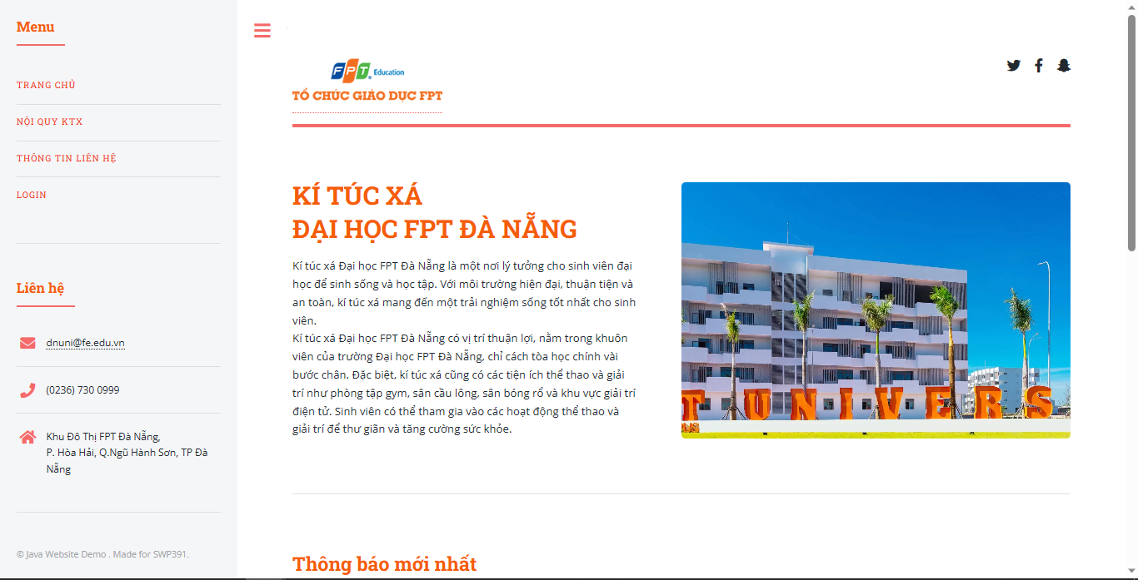

Figure . Step 2 in View Homepage

*3.2.2 Sign up*

1. **Sign up with Fdorm Account**

This is the function to Sign up to Fdorm Website using a Fdorm Account.

* + Step 1: Access Landing page with the URL: develop.fdorm.com
  + Step 2: Click on “LOGIN” button in Homepage

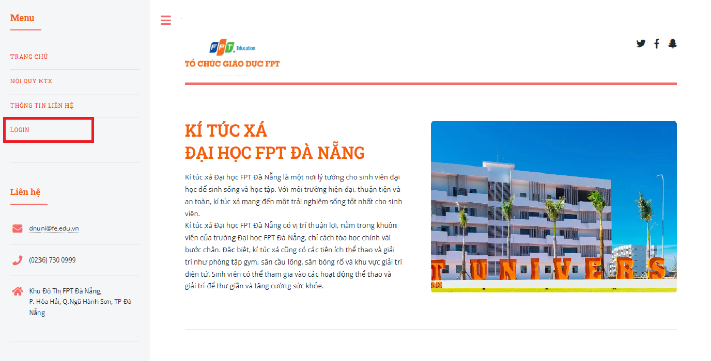

Figure . Step 2 in Sign up with Fdorm Account

* + Step 3: System redirect to sign-in page
  + Step 4: Click on “Tạo tài khoản”

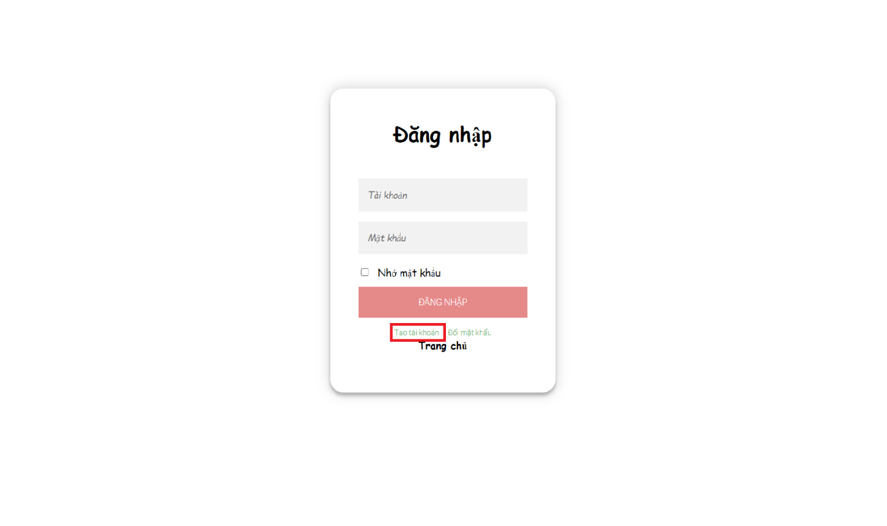

Figure . Step 4 in Sign up with Form Account.

* + Step 5: Type in all the required fields needed to create account

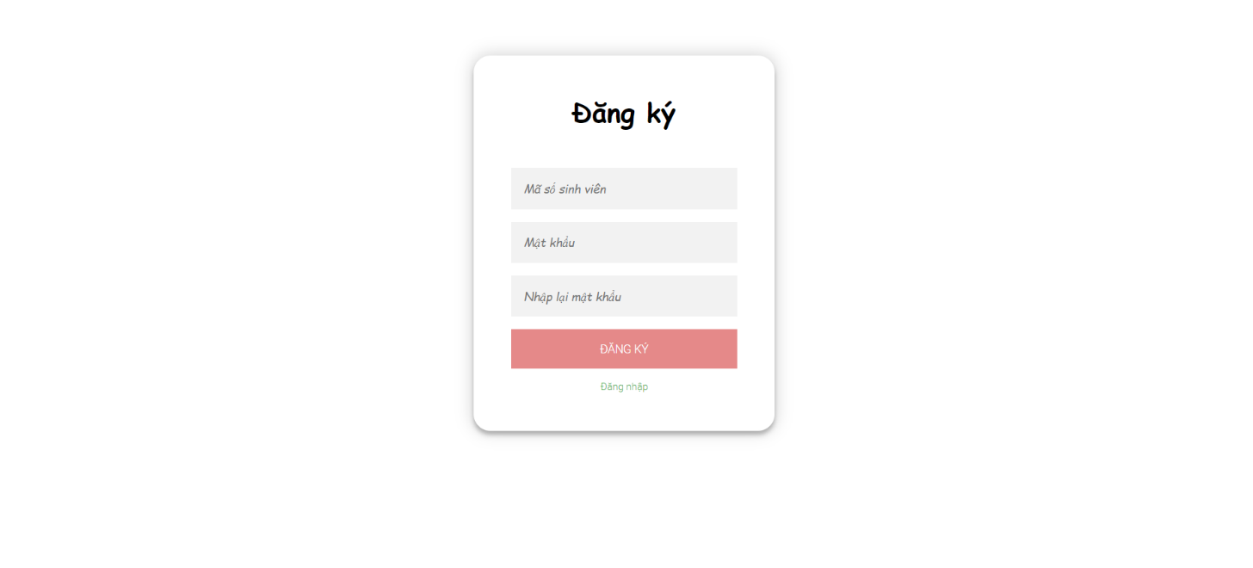

Figure . Step 5 in Sign up with Fdorm Account

● Step 6: Click on button



*3.2.3 View announcements and Dormitory overview*

1. **View notifications****in Homepage**

This function displays the available notificationson the Fdorm website's homepage.

* + Step 1: Access Homepage with the URL: develop.fdorm.com
  + Step 2: System displays all the notificationsin Fdorm homepage



Figure . Step 2 in View notifications in Homepage

1. **View Dormitory Rules**

This function displays the dormitory rules on the home page of the Fdorm website.

* + Step 1: Click on “NỘI QUY KTX”
  + Step 2: The system displays the rules of the dormitory

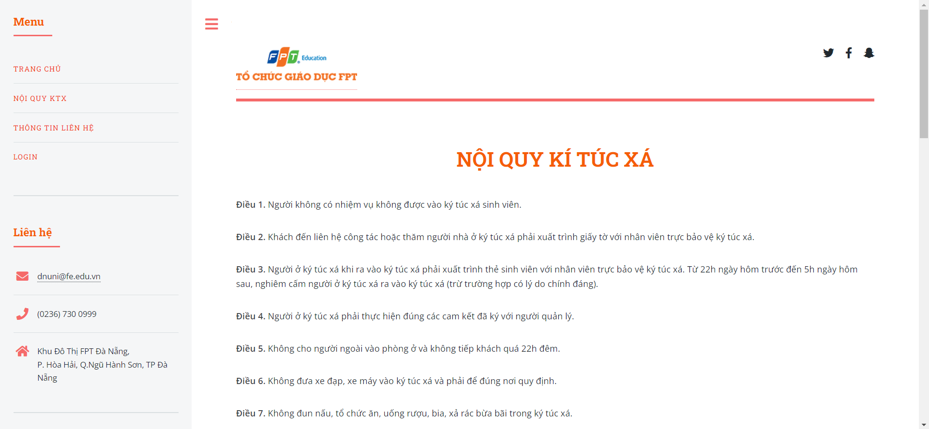

Figure . Step 2 in View a Course’s Overview

*3.2.4* Send contact information to the dormitory

This function allows guests to send contact information to the dormitory

* + Step 1: Click on “THÔNG TIN LIÊN HỆ”
  + Step 2: The system will redirect to the contact information page
  + Step 3: Input in all the required fields needed to send contact information

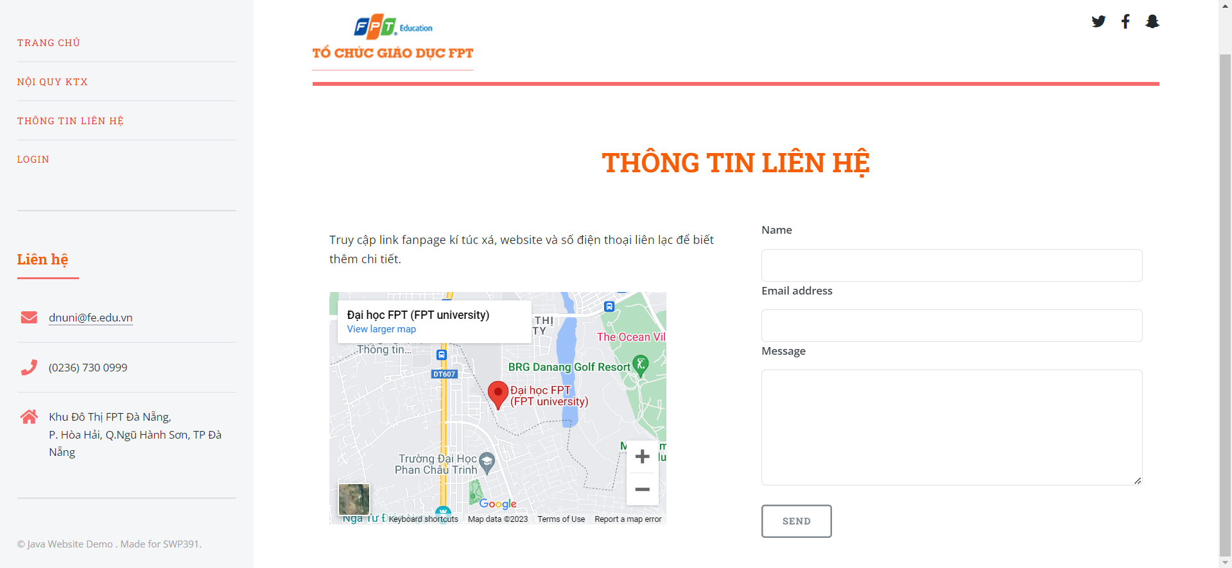

Figure . Step 3 in send contact information to the dormitory

* + Step 4: Click “SEND” button

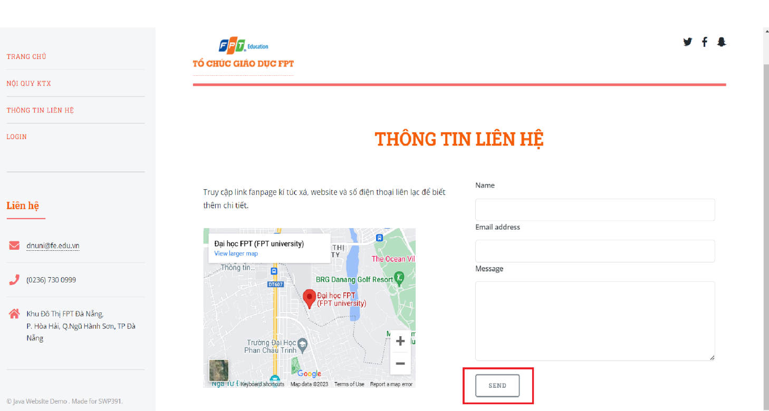

Figure . Step 4 in send contact information to the dormitory

### 3.3 User Manual Guide for User

*3.3.1 Sign In, Sign out*

1. **Sign In**

This is the function to log in to the Fdorm website using a registered account.

* + Step 1: Access Landing page with the URL: develop.fdorm.com
  + Step 2: Click on “LOGIN” button in Homepage



Figure . Step 2 in Sign In

* + Step 3: System redirect to sign-in page
  + Type in the fields to Sign in with Fdorm account

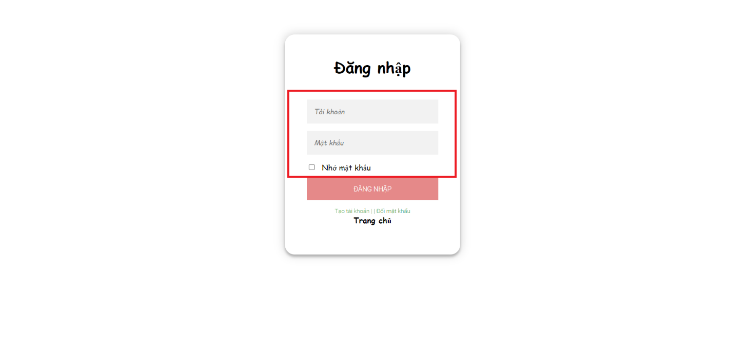

Figure . Step 3 in Sign In

* + Step 5: Click on button



* + Step 6: System will redirect to Homepage

1. **Sign Out**

This is the function to log out of the FLearning website and end the current session.

* + Step 1: Access the Homepage with an account
  + Step 2: Click on “ĐĂNG XUẤT”

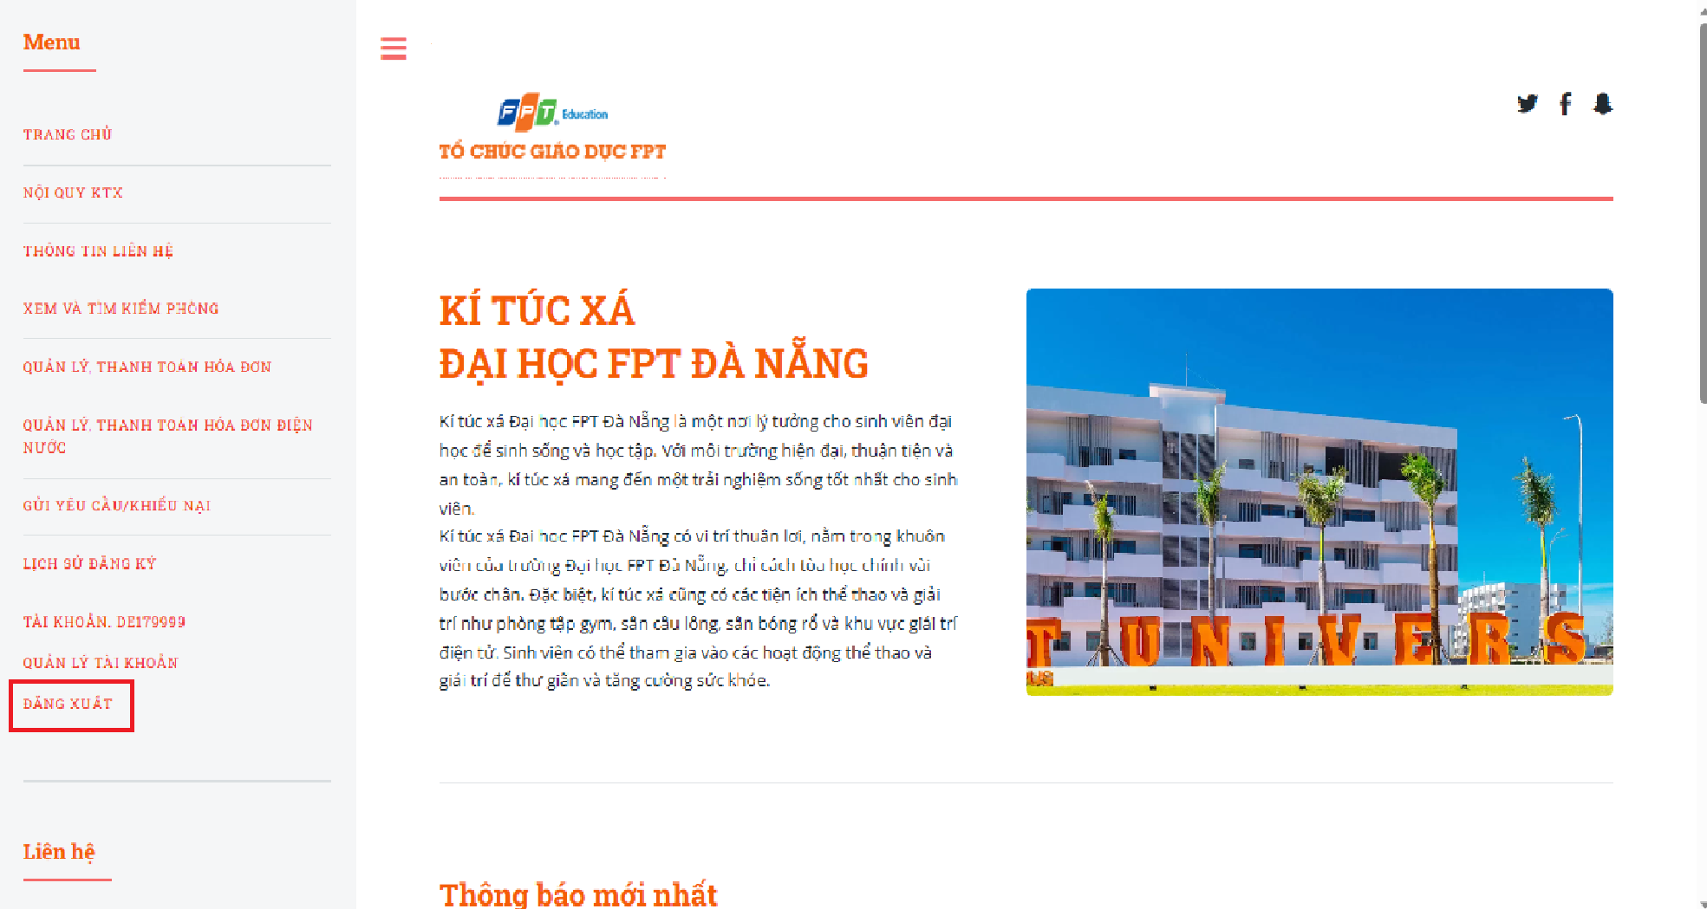

Figure . Step 2 in Sign Out

*3.3.2 Change password*

This is the function to modify a user's password on the Fdorm website.

* Step 1: Access the Homepage
* Step 2: Click on “LOGIN”



Figure . Step 2 in Change password

* Step 4: System redirect to sign-in page
* Step 5: Click on “Đổi mật khẩu”

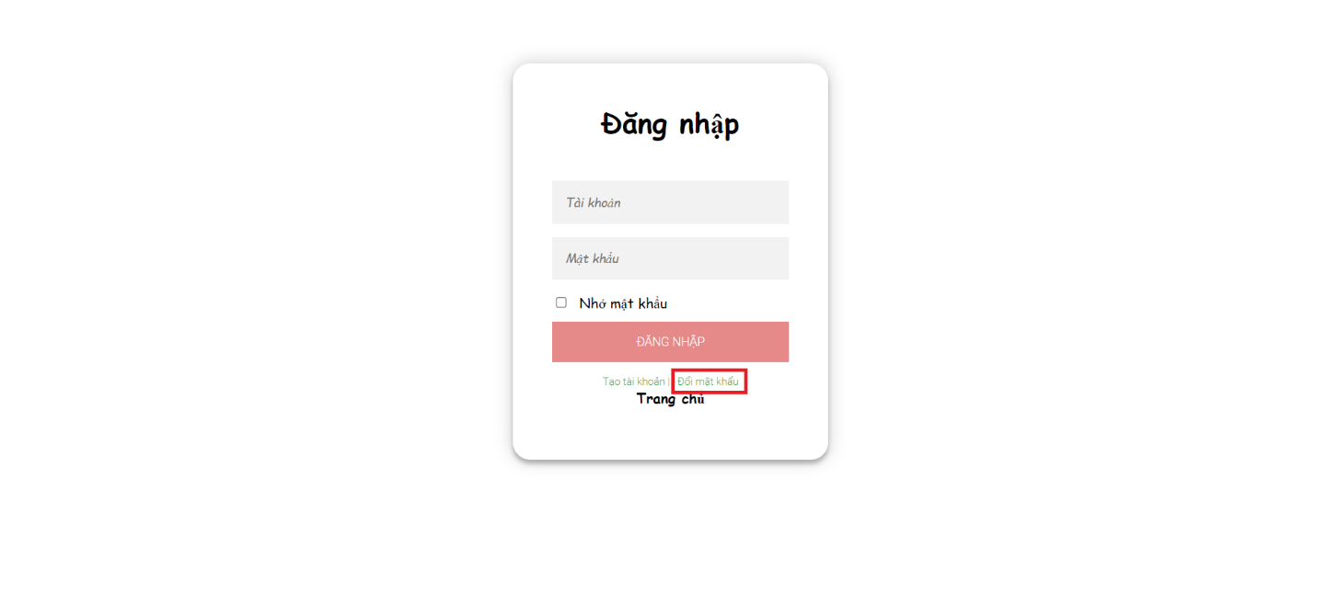

Figure . Step 5 in Change password

* Step 6: System redirect to change password page
* Step 7: Type in the fields to change password

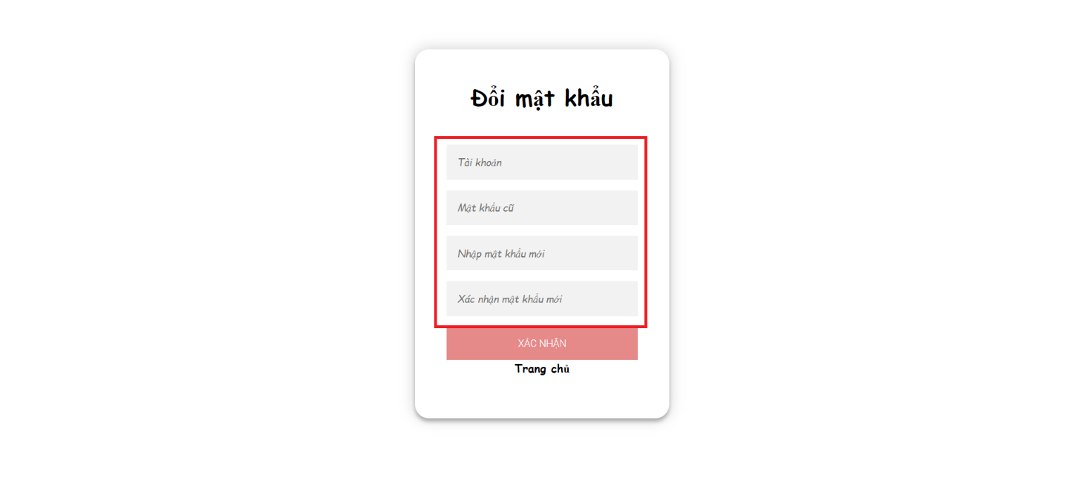

Figure . Step 7 in Change password

* Step 8 : Click on “XÁC NHẬN” button



*3.3.3 Search and book room*

1. **Search room**

This is a function for users to search for rooms on the Fdorm website.

* Step 1: Access Homepage with an account.
* Step 2: Click on “XEM VÀ TÌM KIẾM PHÒNG”

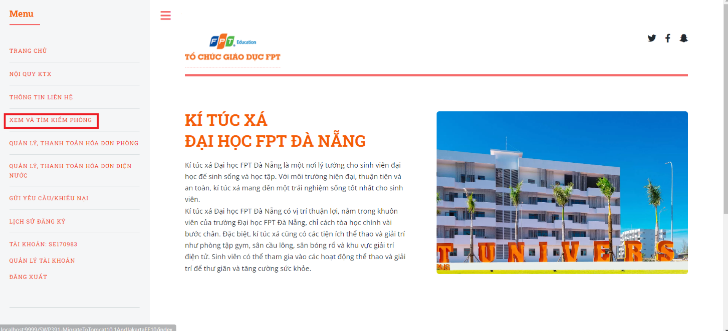

Figure . Step 2 in search room

* Step 3: The system will display a list of dorm rooms.
* Step 4: Type and select the search fields to find rooms

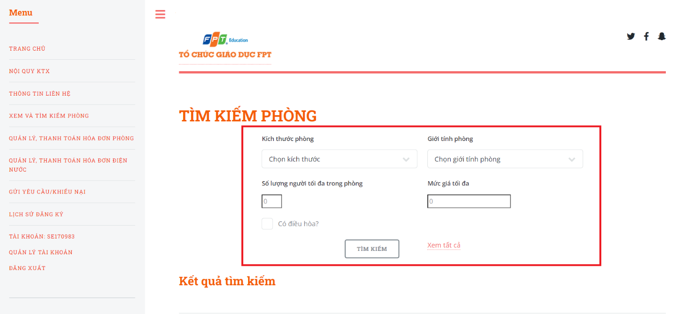

Figure . Step 4 in search room

* Step 5: Click on “TÌM KIẾM” button

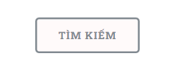

1. **Book a room**

This is a function for users to book a room on Fdorm's website.

* Step 1: Access Homepage with an account.
* Step 2: Click on “XEM VÀ TÌM KIẾM PHÒNG”



Figure . Step 2 in book a room

* Step 4: The system displays all rooms, click on “Đăng ký” button

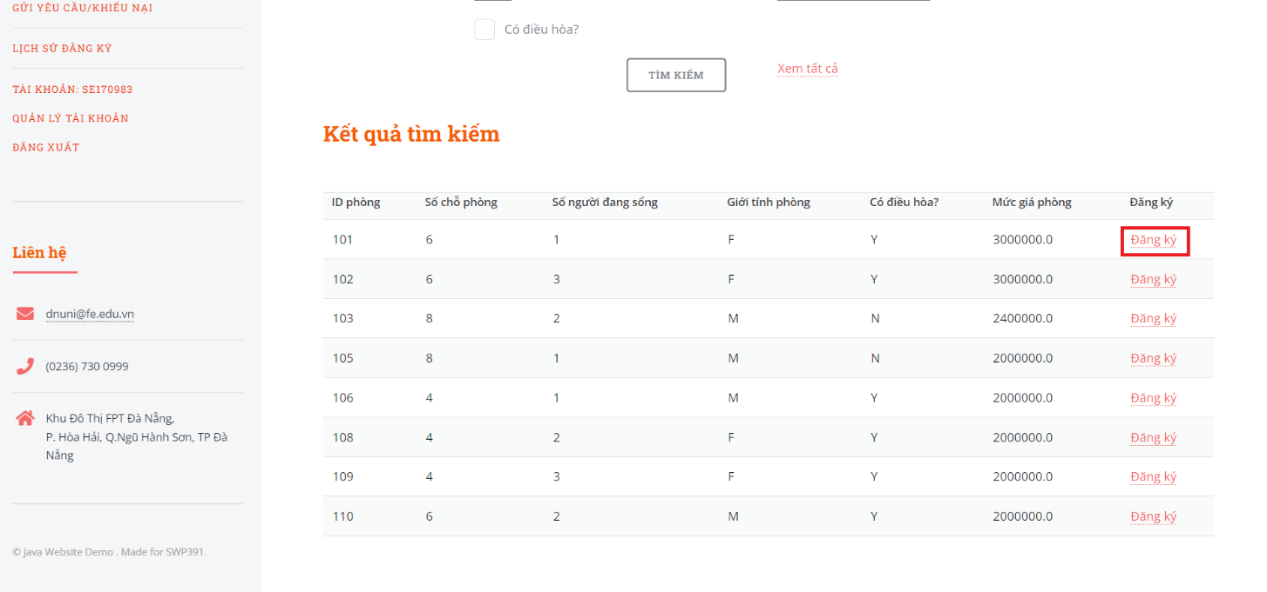

Figure . Step 4 in book a room

* Step 5: The system redirects to the room registration page, click on “XÁC NHẬN ĐĂNG KÝ” button

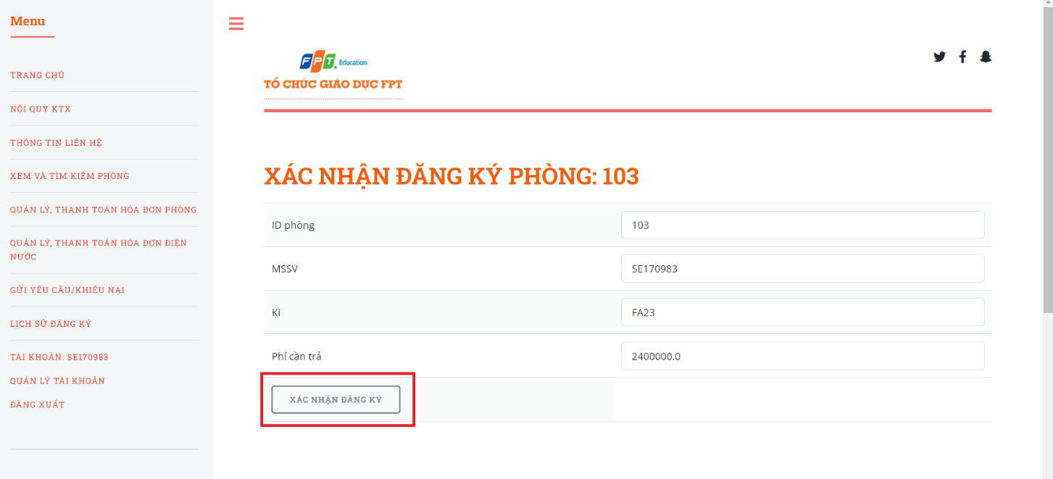

Figure . Step 5 in book a room

*3.3.4 Payment*

1. **Room payment**

This is a function that allows users to pay for rooms on Fdorm's website.

* Step 1: Access Homepage with an account.
* Step 2: Click on “QUẢN LÝ, THANH TOÁN HÓA ĐƠN PHÒNG”

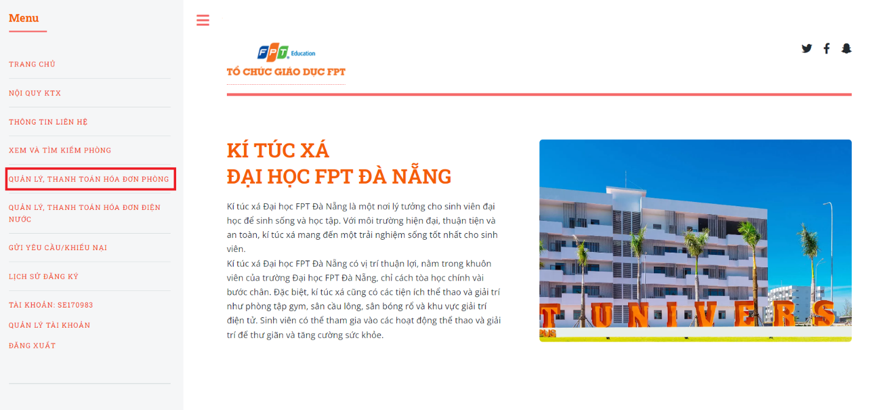

Figure . Step 2 in room payment

* + Step 3: The system will display the information of the room bill, Click on “THANH TOÁN” button.

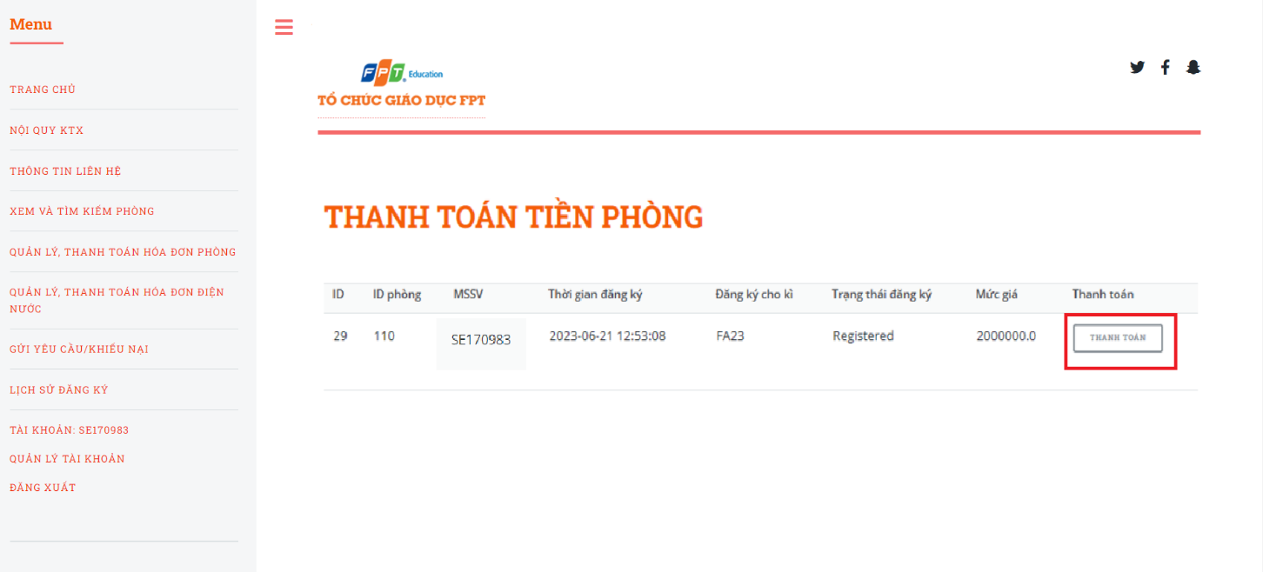

Figure . Step 3 in room payment

1. **Electricity and water payment**

This is a function that allows users to pay electricity and water bills on Fdorm's website.

* Step 1: Access Homepage with an account.
* Step 2: Click on “QUẢN LÝ, THANH TOÁN HÓA ĐƠN ĐIỆN NƯỚC”

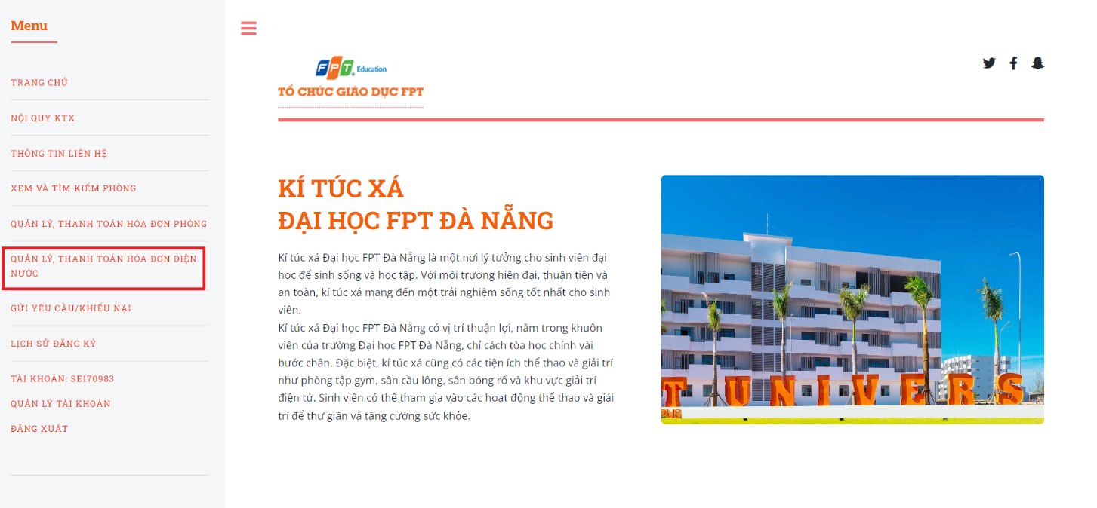

Figure . Step 2 in electricity and water payment

* Step 3: The system will display the information of the room bill, Click on “Thanh toán” button

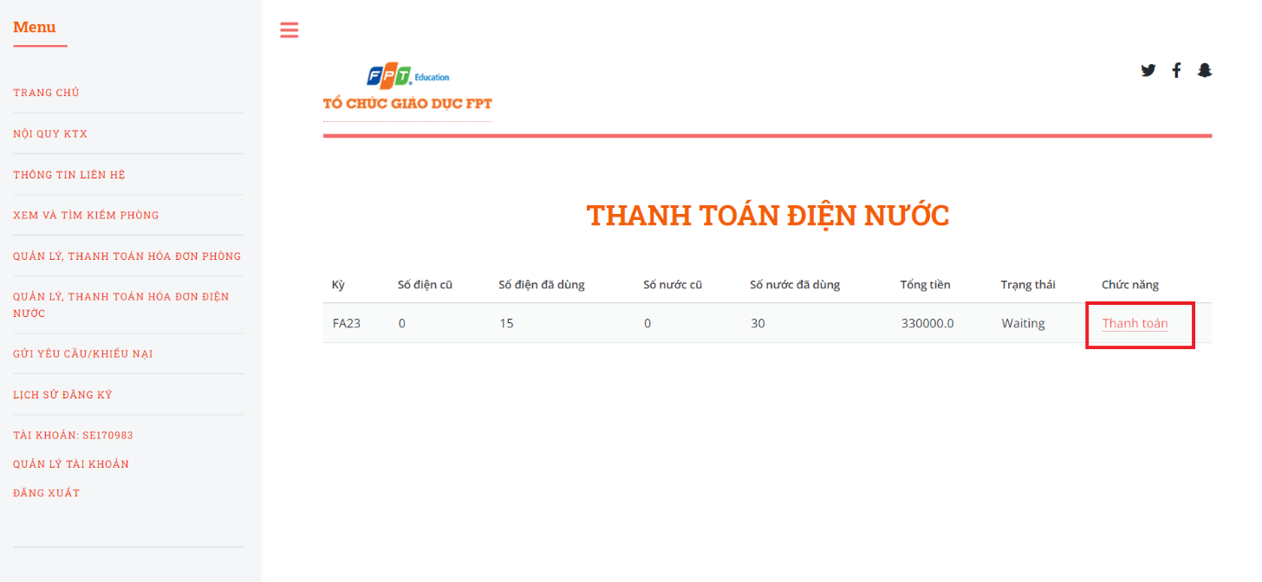

Figure . Step 3 in electricity and water payment

*3.3.5 Send require*

1. **Send request to change room**

This is a function that allows users to send room change requests on Fdorm's website.

* Step 1: Access Homepage with an account.
* Step 2: Click on “GỬI YÊU CẦU KHIẾU NẠI”

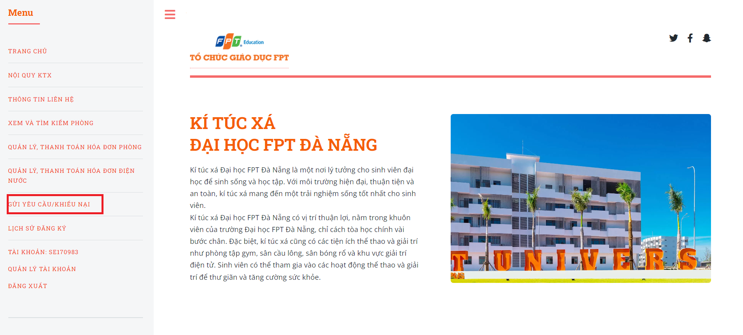

Figure . Step 2 in send request to change room

* Step 3: Select request type “Đổi phòng” and lick on “CHỌN”button

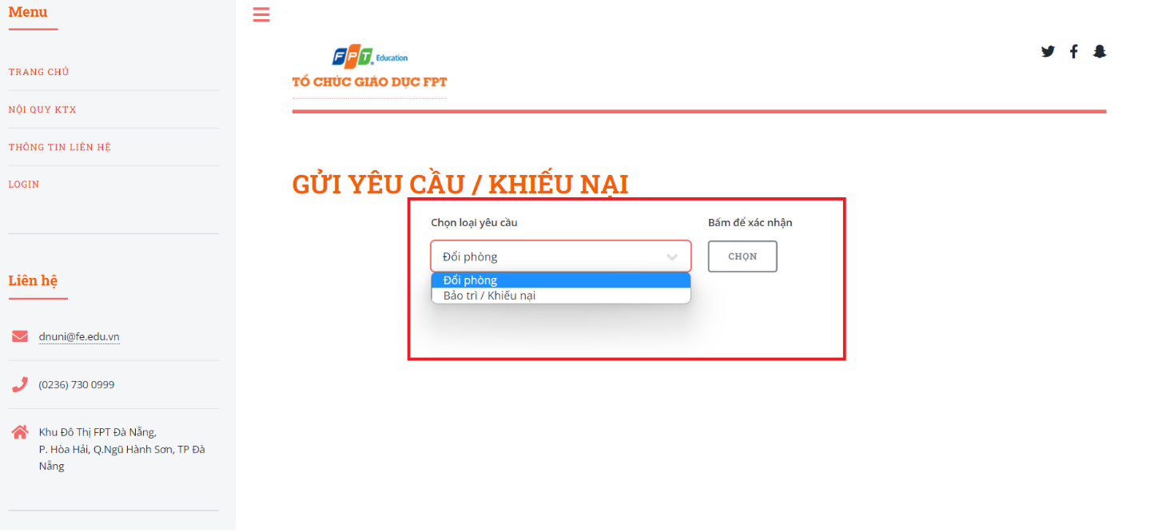

Figure . Step 3 in send request to change room

* Step 4: Input in all the required fields needed to send request change room

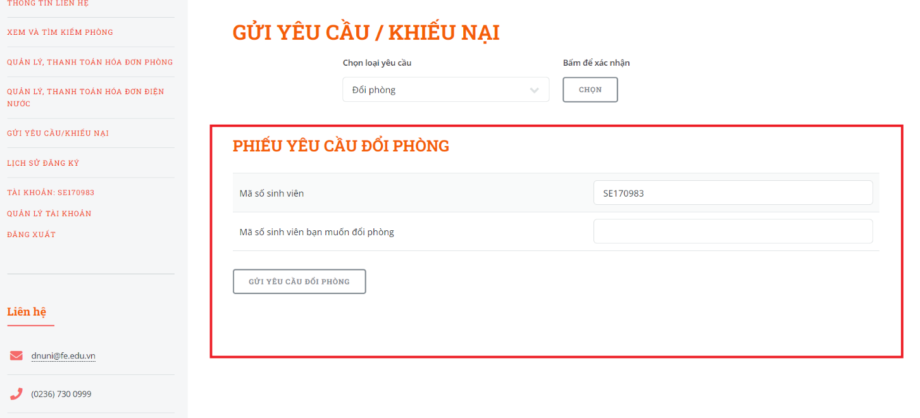

Figure . Step 4 in send request to change room

* Step 5: Click the button “GỬI YÊU CẦU ĐỔI PHÒNG”

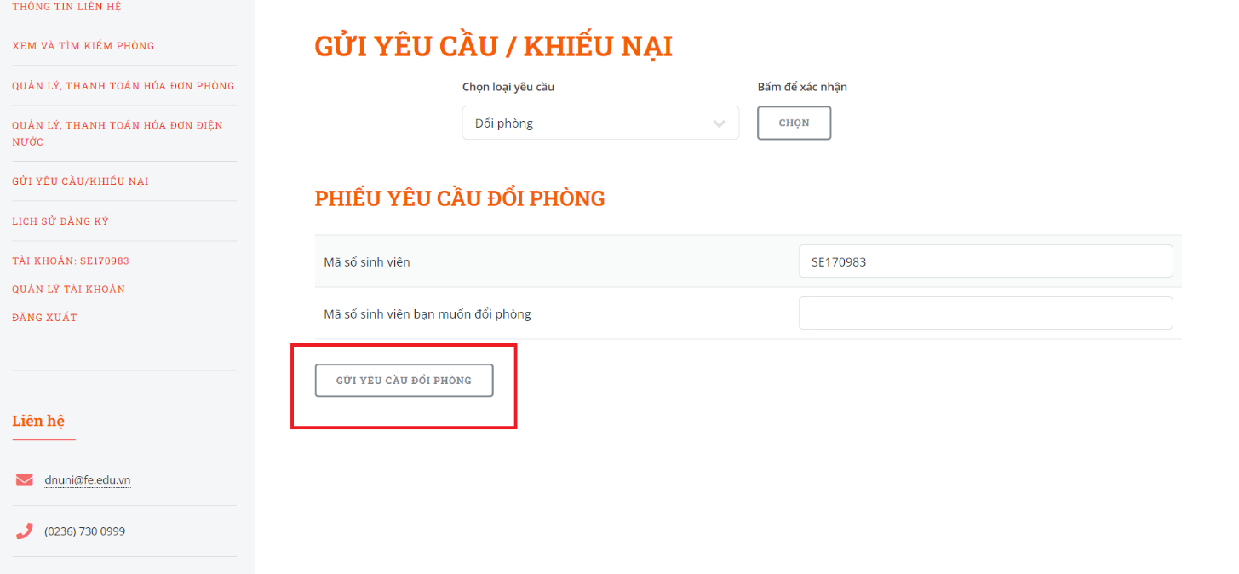

Figure . Step 5 in send request to change room

1. **Send maintenance, complaints requests.**

This is a function that allows users to send maintenance, complaints requests on Fdorm's website.

* Step 1: Access Homepage with an account.
* Step 2: Click on “GỬI YÊU CẦU KHIẾU NẠI”



Figure . Step 2 in send request to maintenance, complaints

* Step 3: Select request type “Bảo trì / Khiếu nại” and lick on “CHỌN”button

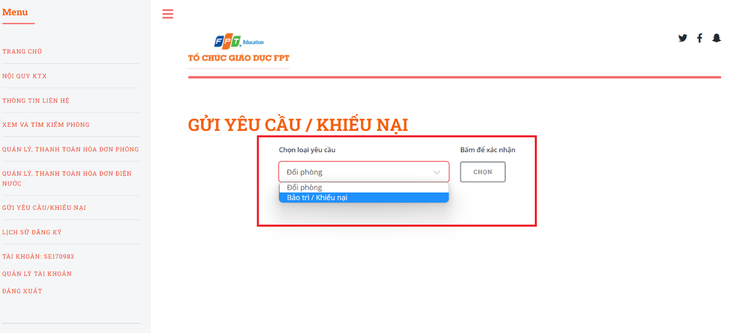

Figure . Step 3 in send request to maintenance, complaints

* Step 4: Input in all the required fields needed to send maintenance, complaints requests

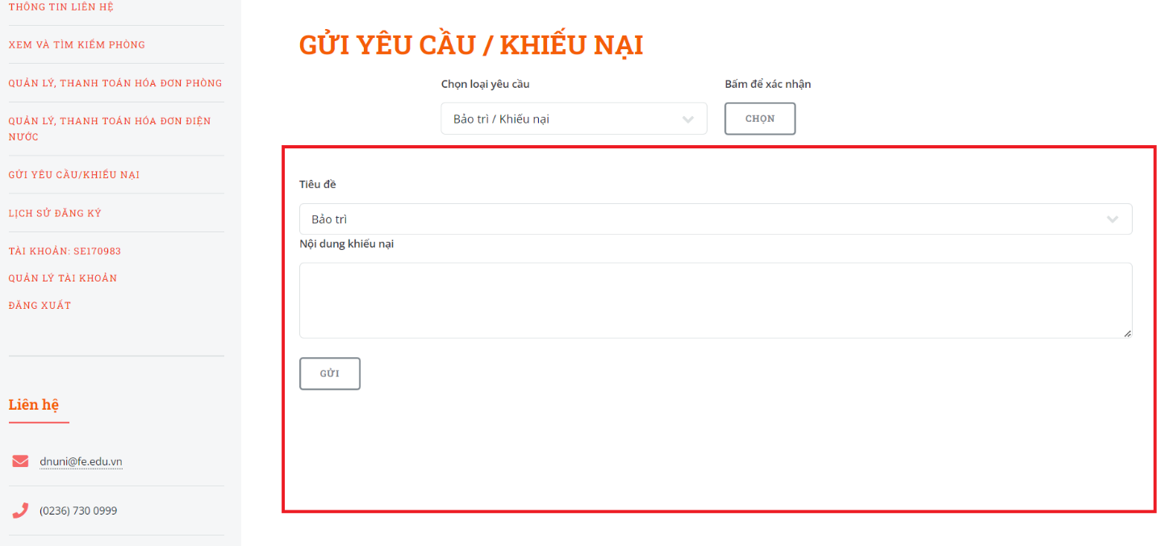

Figure . Step 4 in send request to maintenance, complaints

* Step 5: Click the button “GỬI”

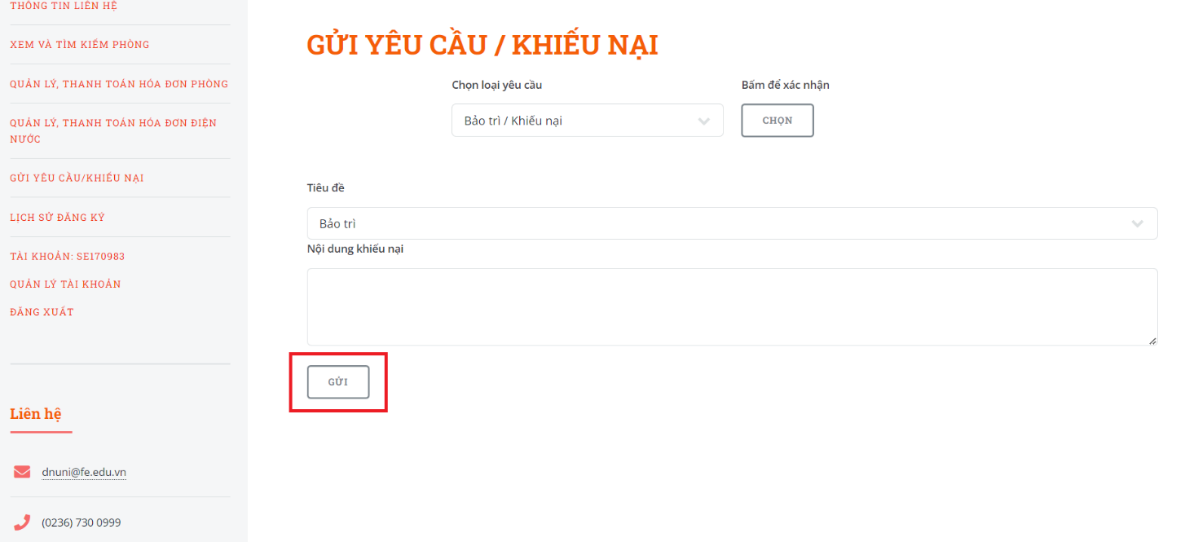

Figure . Step 5 in send request to maintenance, complaints

*3.3.6 View room registration history*

This is a function that allows users to view room registration history on Fdorm's website.

* Step 1: Access Homepage with an account.
* Step 2: Click on “LỊCH SỬ ĐĂNG KÝ”, the system displays room registration history

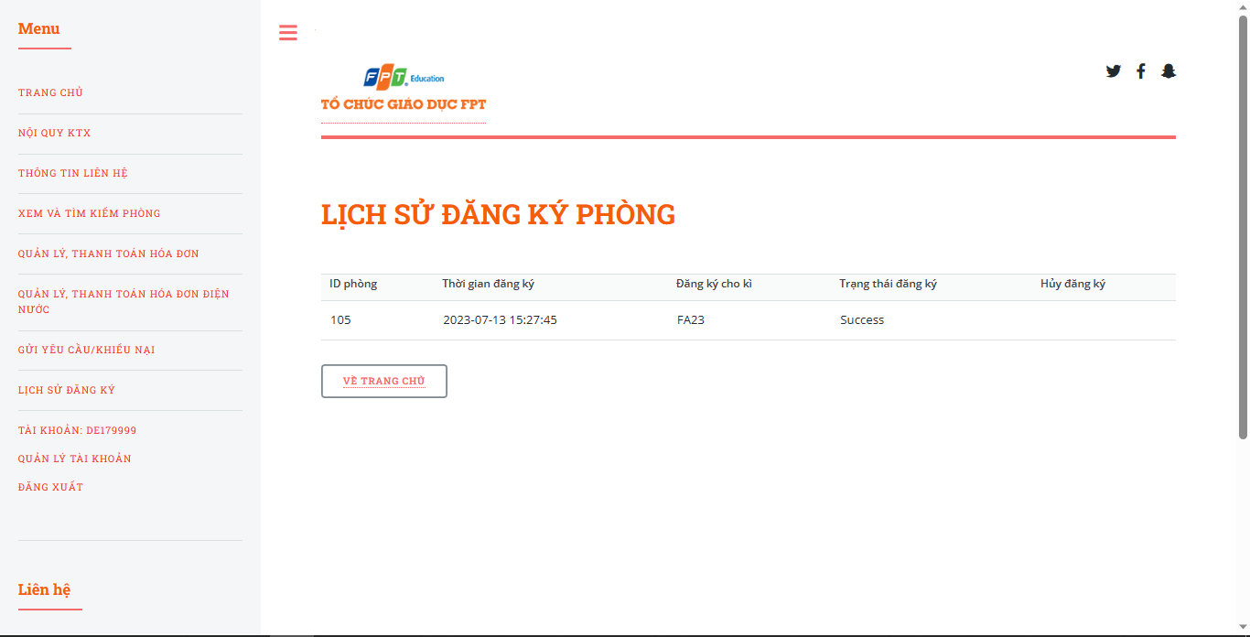

Figure . Step 2 in view room registration history

* + Step 3: Click on “VỀ TRANG CHỦ” button to return to the homepage.

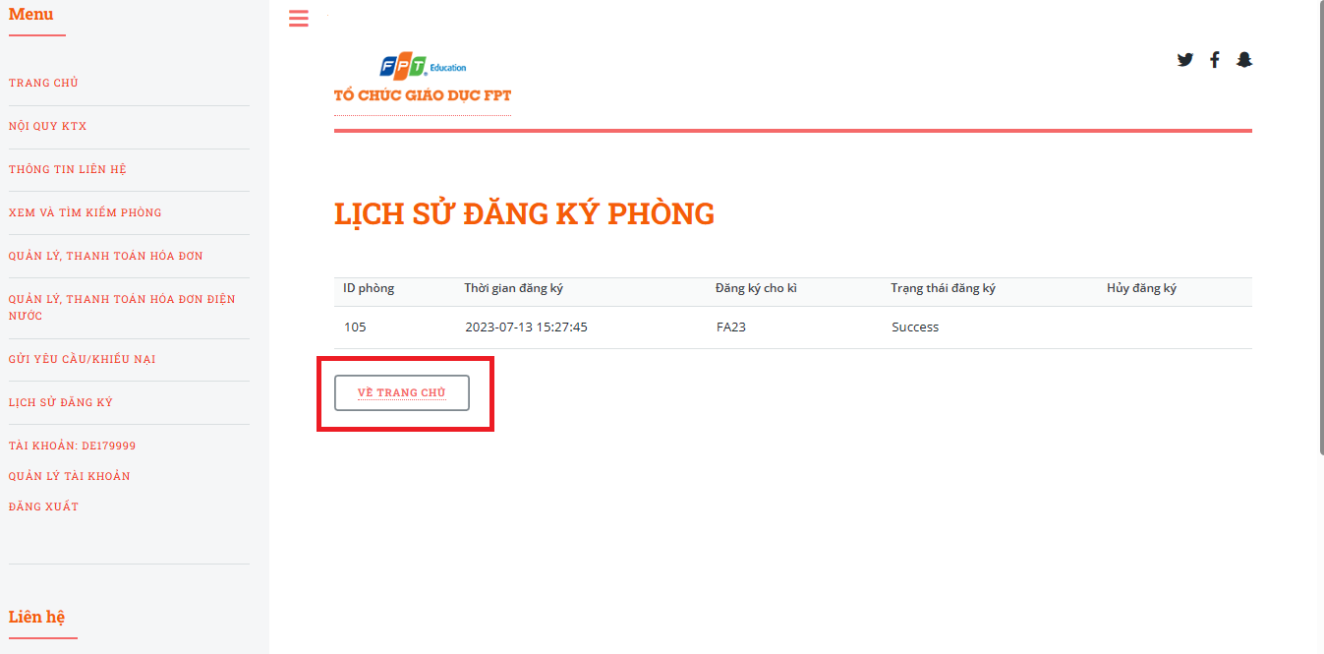

Figure . Step 3 in view room registration history

*3.3.7 Update profile*

This function allows users to update personal information.

* Step 1: Access Homepage with an account.
* Step 2: Click on “QUẢN LÝ TÀI KHOẢN”

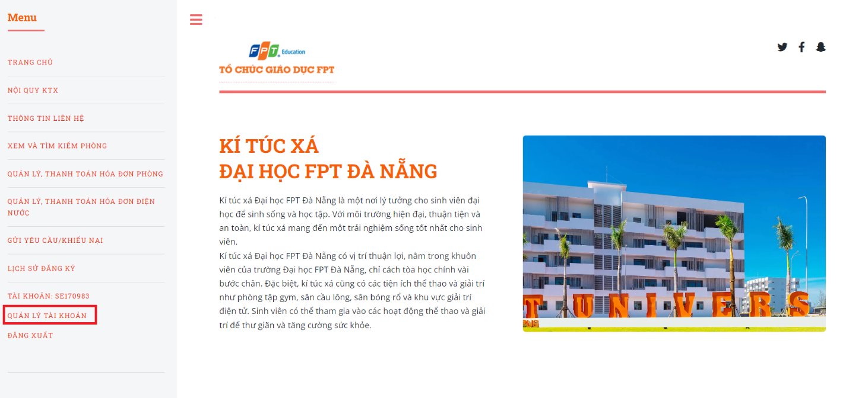

Figure . Step 2 in update profile

* + Step 3: Input the fields that the user wants to edit

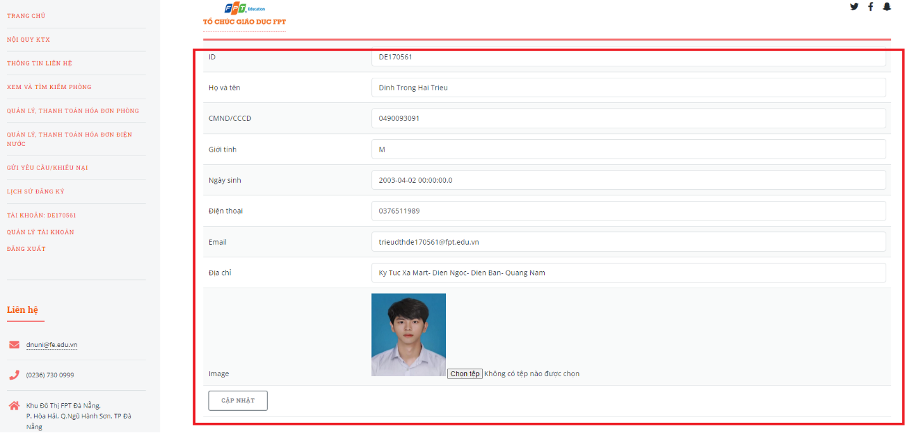

Figure . Step 3 in update profile

* + Step 4: Click on “CẬP NHẬT” button

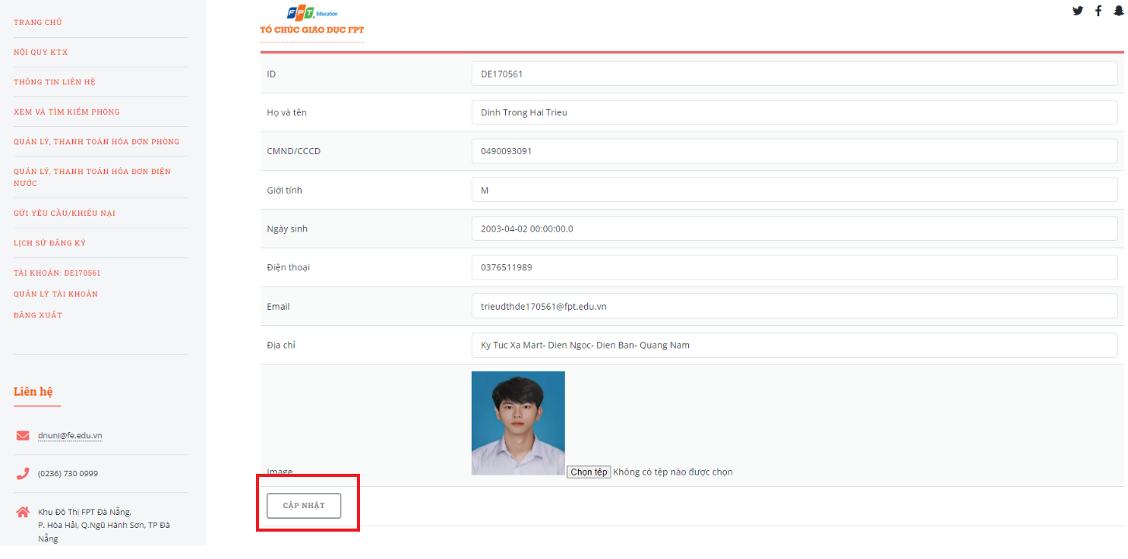

Figure . Step 4 in update profile

### 3.4 User Manual Guide for Admin

*3.5.1 Manage notifications*

1. **View all notifications to manage.**

This function allows Admin to view the notifications of the Fdorm website.

* Step 1: Access the Home page with an admin account.
* Step 2: Click on “QUẢN LÝ THÔNG BÁO”

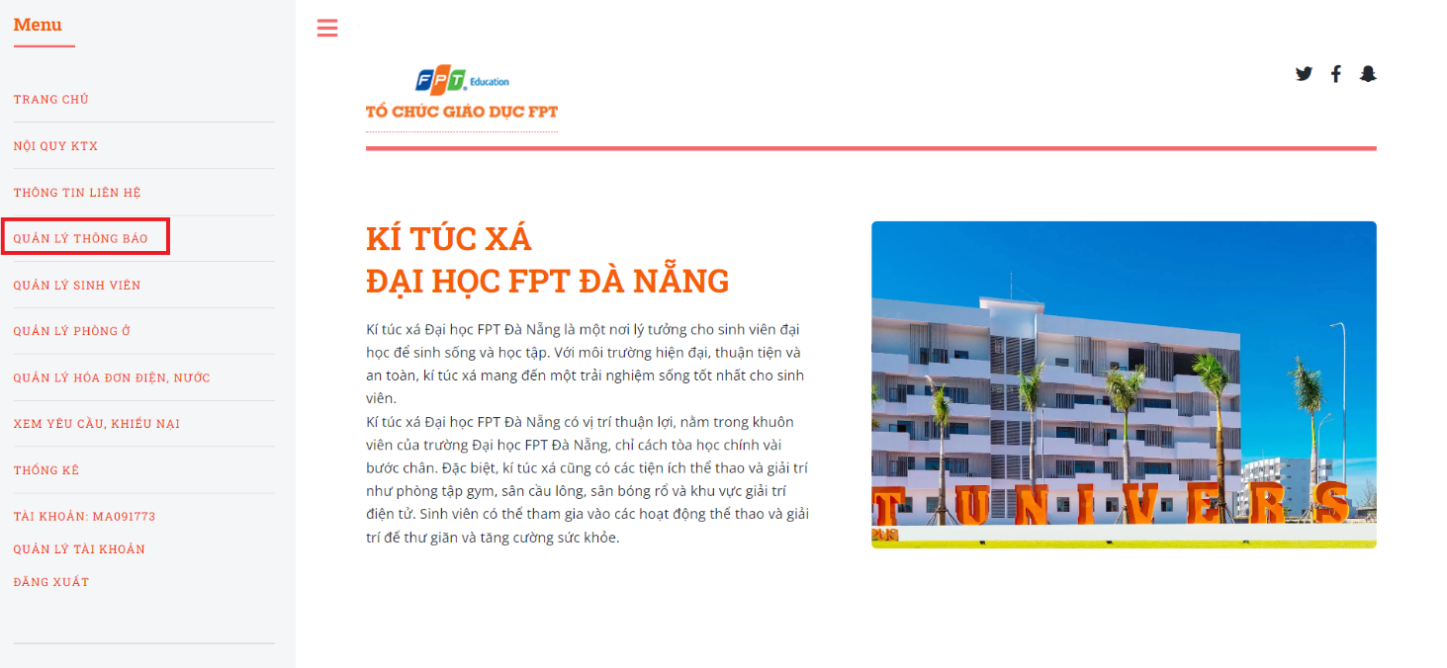

Figure . Step 2 in view notifications

* Step 3: The system displays all notifications for management

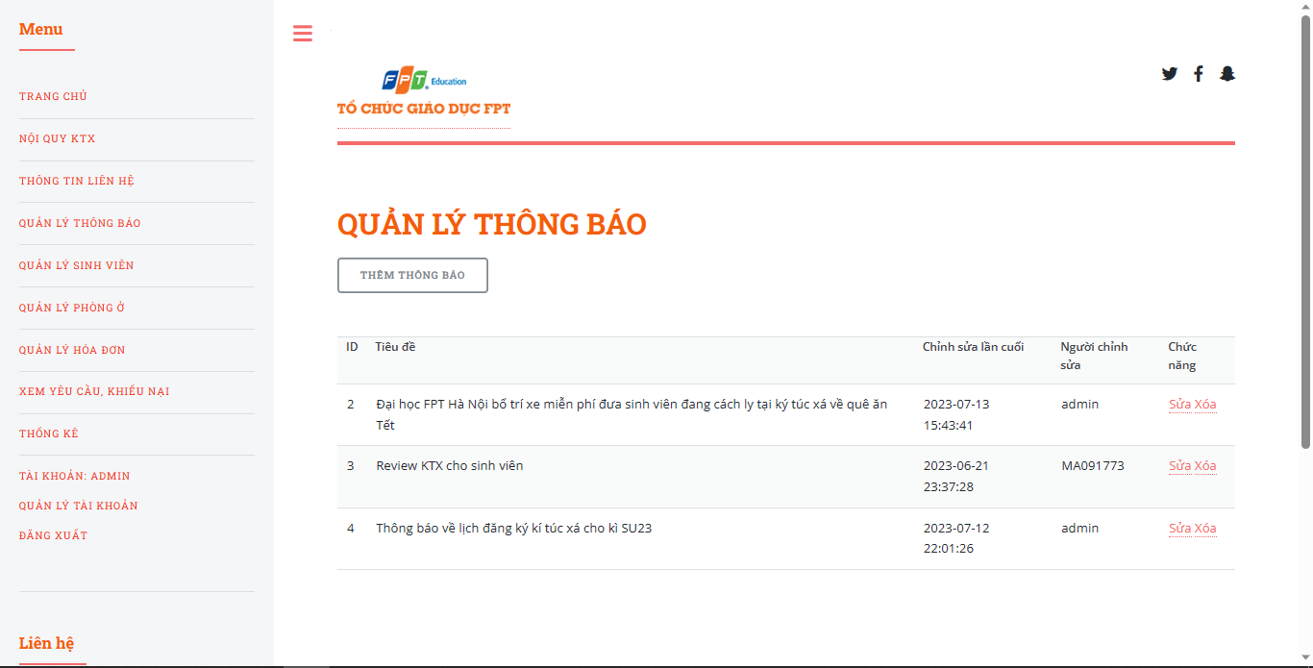

Figure . Step 3 in view notifications

1. **Create a notification.**

This function allows the Admin to create the notification of the Fdorm website.

* Step 1: Access “QUẢN LÝ THÔNG BÁO” page.
* Step 2: Click on “THÊM THÔNG BÁO” button.

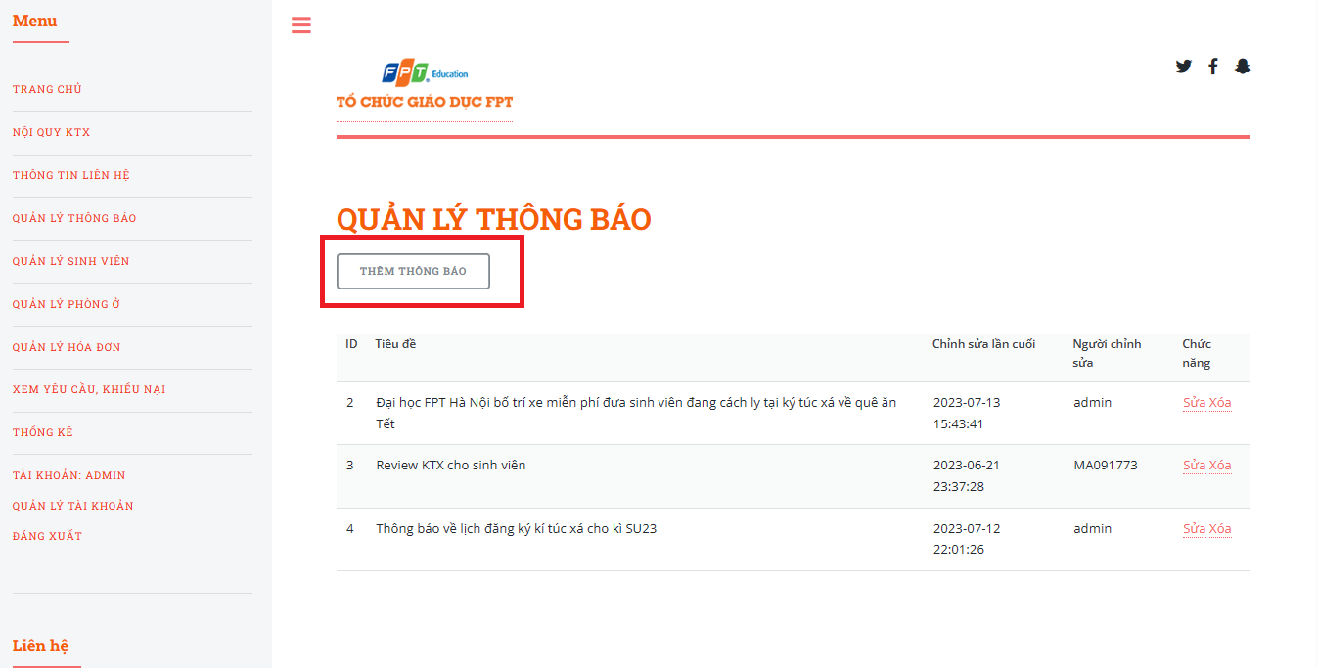

Figure . Step 2 in create notification

* Step 3: The system redirects to the create notification page, input all the fields

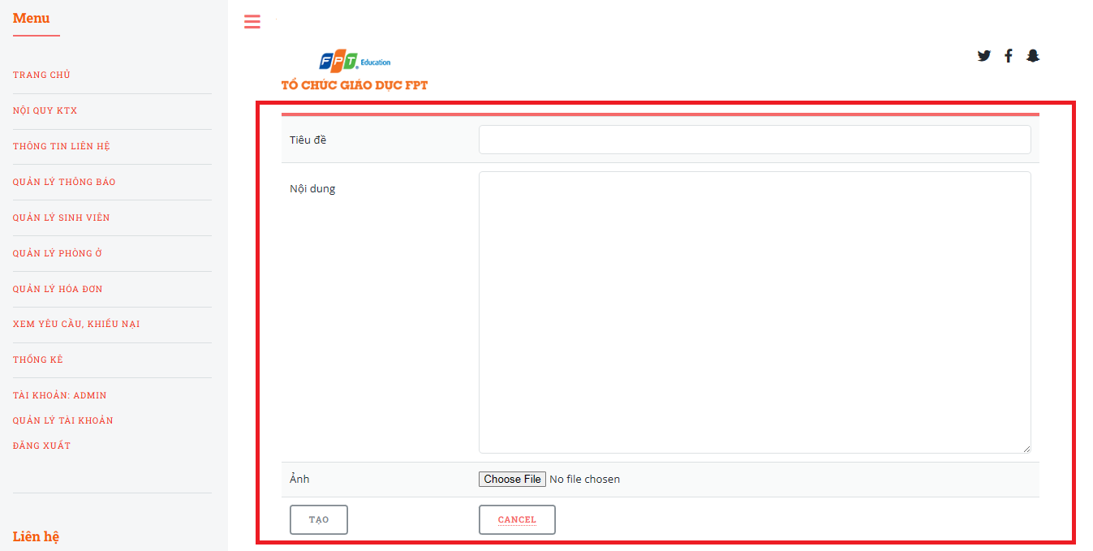

Figure . Step 3 in create notification

* Step 4: Click on “TẠO” button

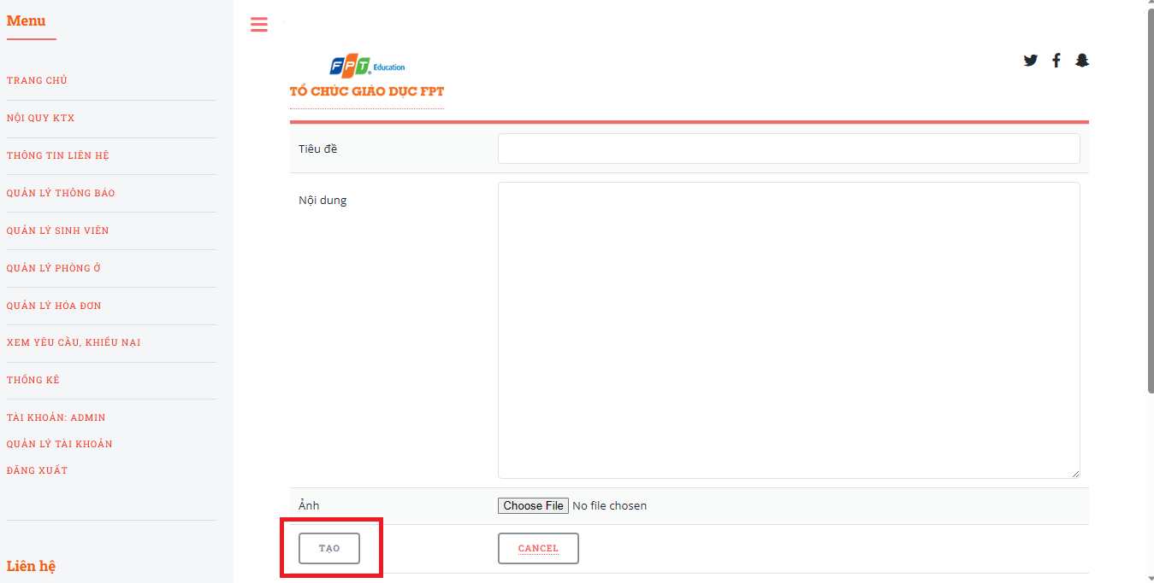

Figure . Step 4 in create notification

1. **Update notifications.**

This function allows the Admin to update the notification of the Fdorm website.

* Step 1: Access “QUẢN LÝ THÔNG BÁO” page.
* Step 2: Click on “Sửa”.

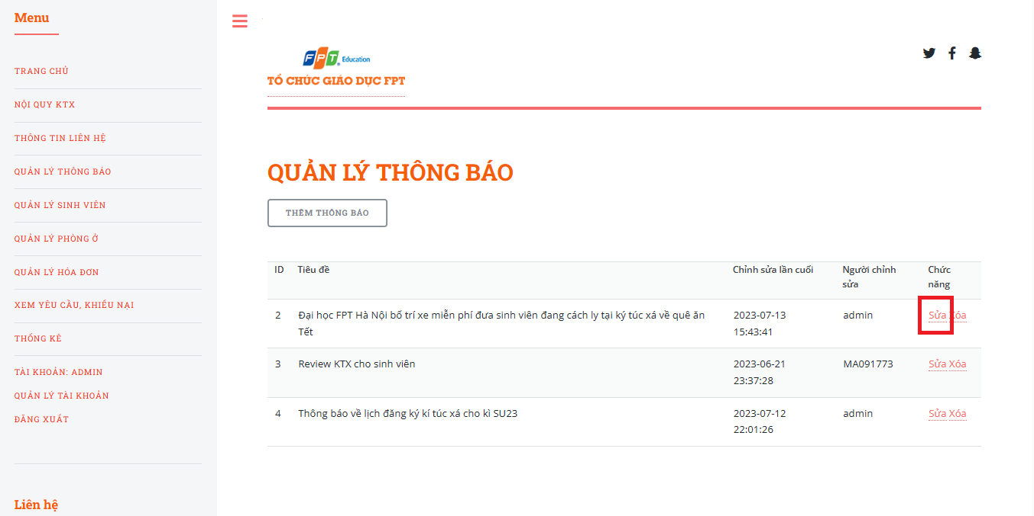

Figure . Step 2 in update notification

* Step 3: The system redirects to the update notification page, input the field that the Addmin wants to change

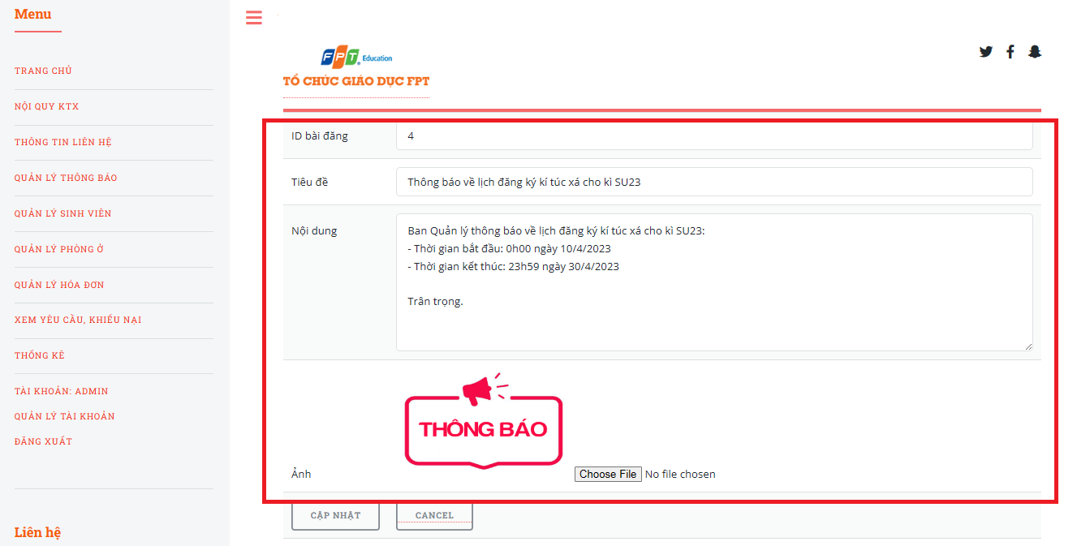

Figure . Step 3 in update notification

* Step 4: Click on “CẬP NHẬT” button

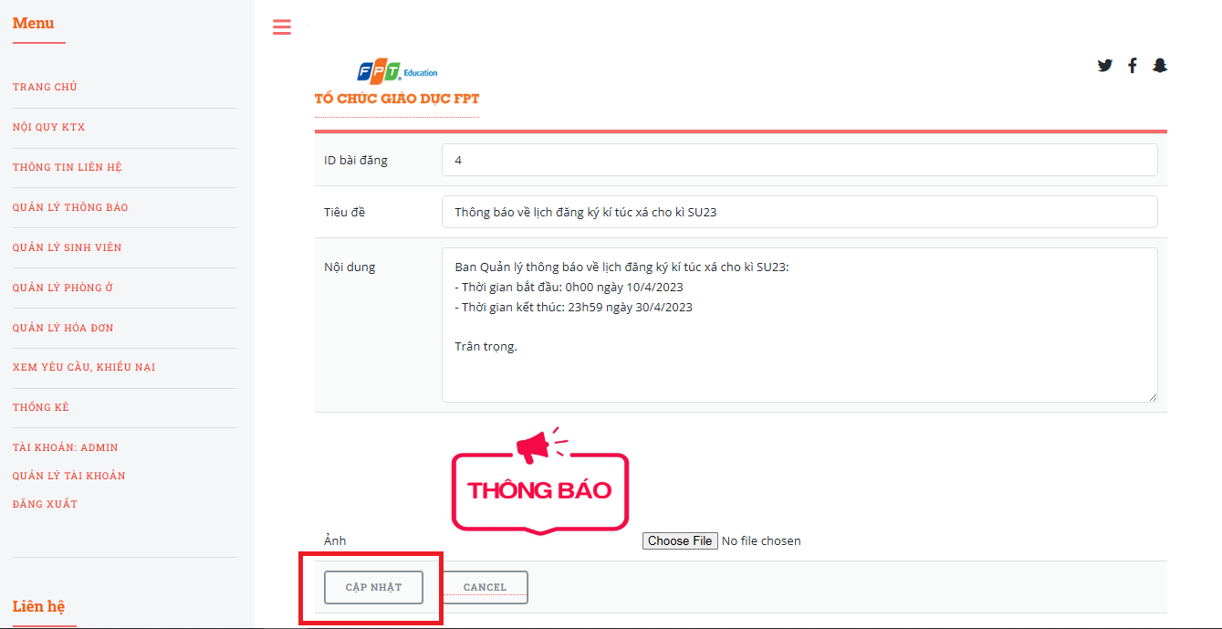

Figure . Step 4 in update notification

1. **Delete notifications.**

This function allows the Admin to delete the notification of the Fdorm website.

* Step 1: Access “QUẢN LÝ THÔNG BÁO” page.
* Step 2: Click on “Xóa”.

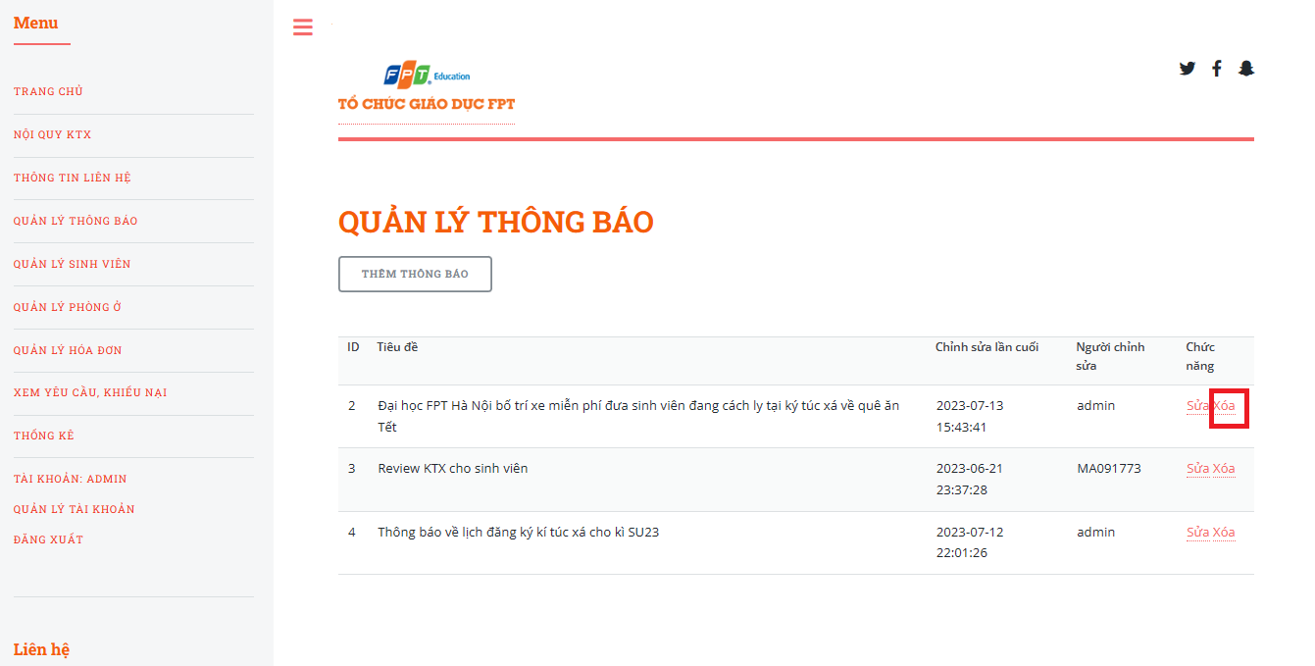

Figure . Step 2 in delete notification

*3.5.2 View, Update student information.*

* 1. **View all student information.**

This function allows Admin to view student information of the Fdorm website.

* Step 1: Access the Home page with an admin account.
* Step 2: Click on “QUẢN LÝ SINH VIÊN”

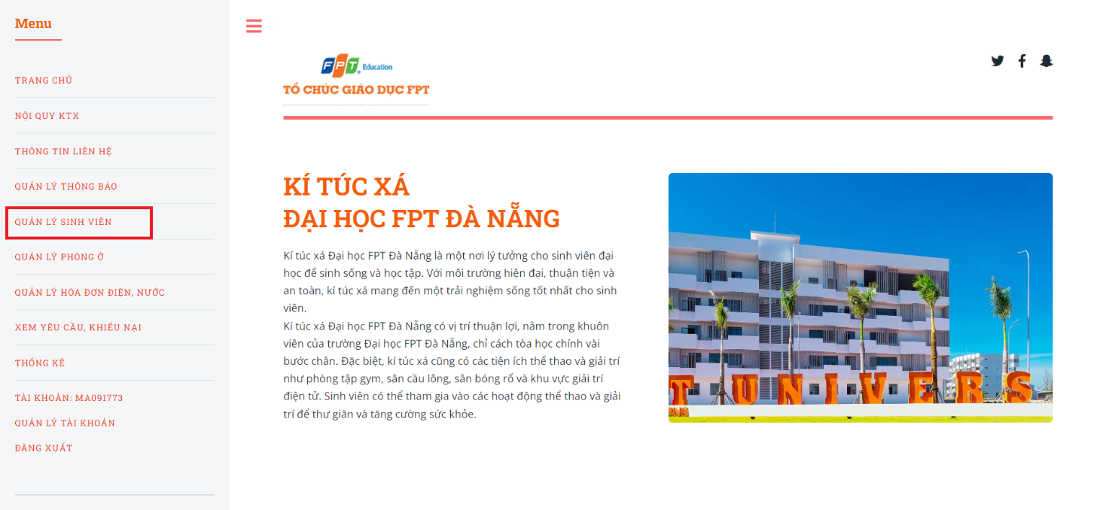

Figure . Step 2 in view student information.

* Step 3: The system displays all student information for management.

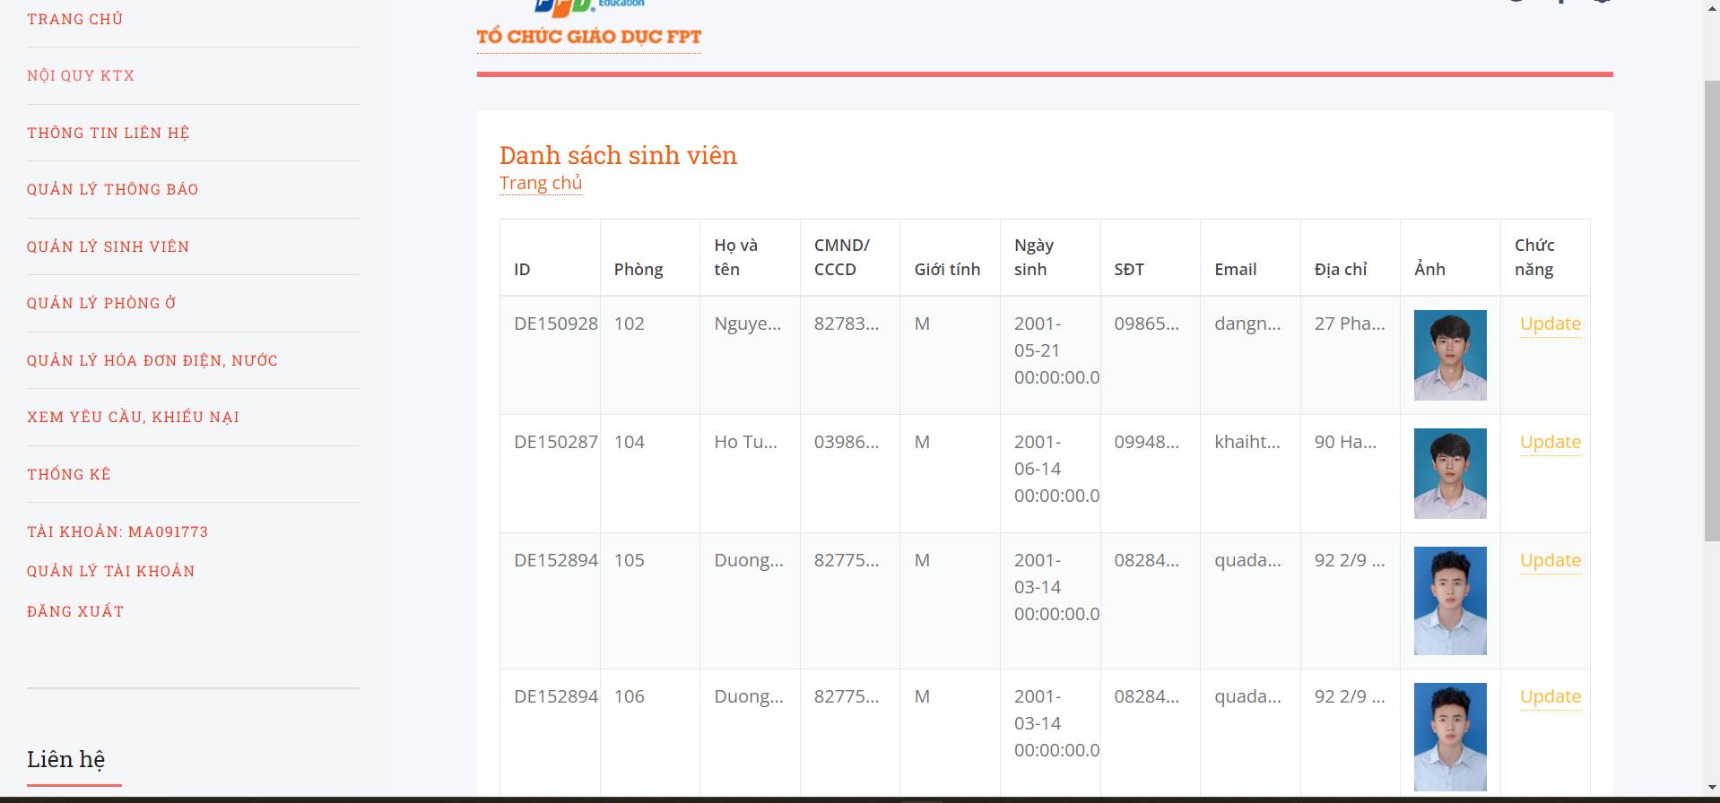

Figure . Step 3 in view student information.

* 1. **Update student information.**

This function allows the Admin to update the student information of the Fdorm website.

* Step 1: Access “QUẢN LÝ SINH VIÊN” page.
* Step 2: Click on “Update”.

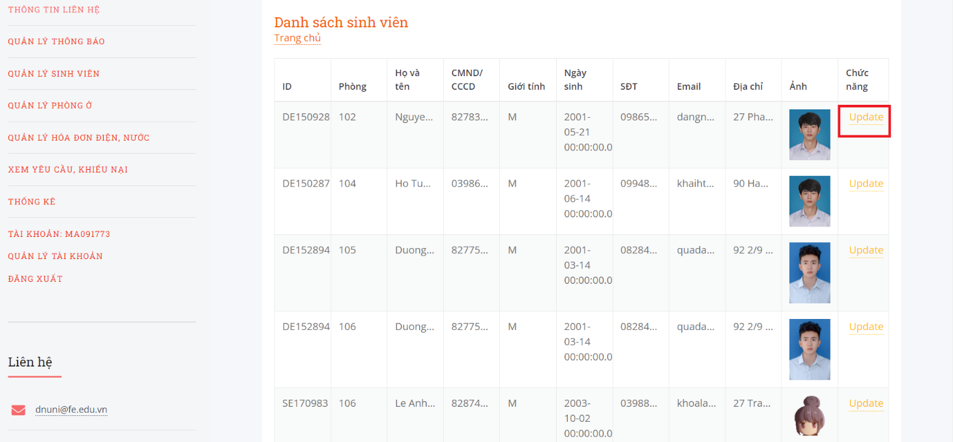

Figure . Step 2 in update student information

* Step 3: The system redirects to the update student information page, input the field that the Addmin wants to change

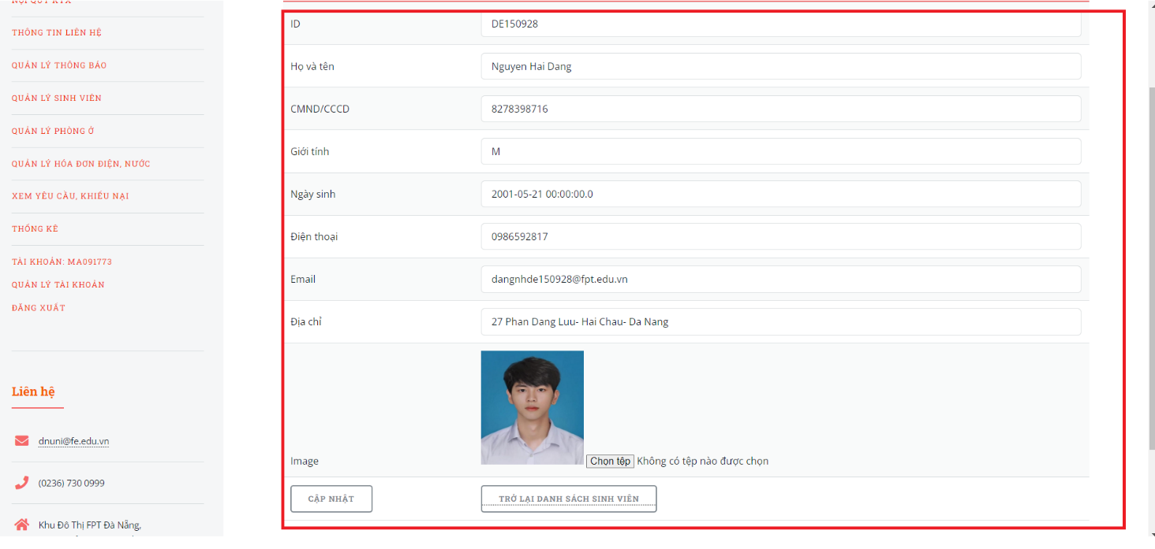

Figure . Step 3 in update student information

* Step 4: Click on “CẬP NHẬT” button

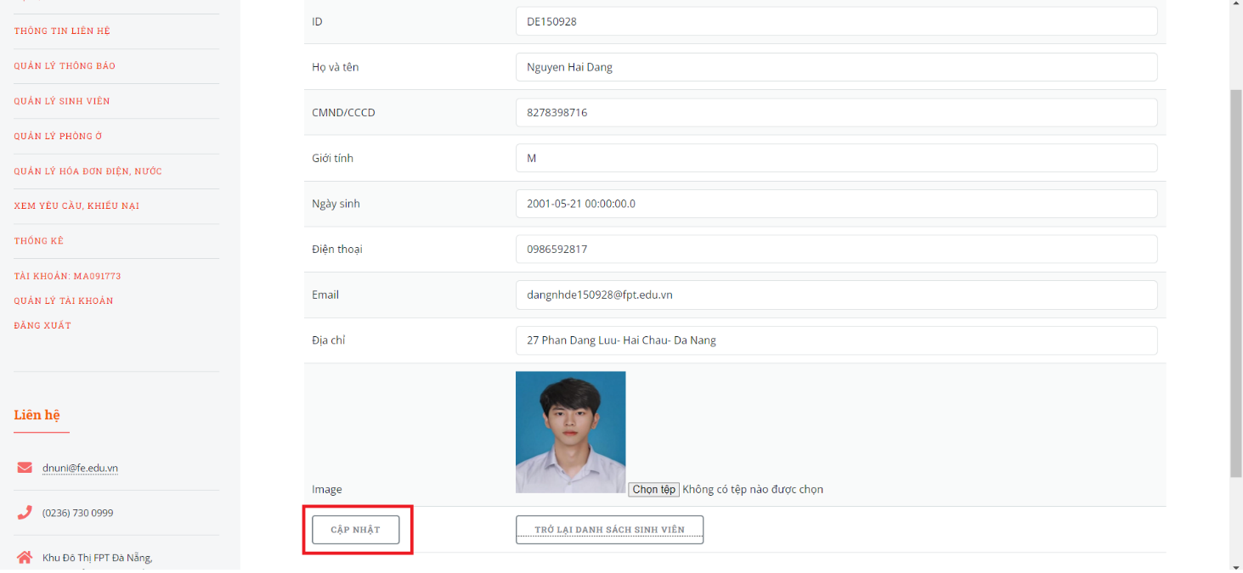

Figure . Step 4 in update student information

*3.5.3 View, Create, Update, Delete room.*

1. **View all room to manage.**

This function allows Admin to view all room of the Fdorm website.

* Step 1: Access the Home page with an admin account.
* Step 2: Click on “QUẢN LÝ PHÒNG Ở”

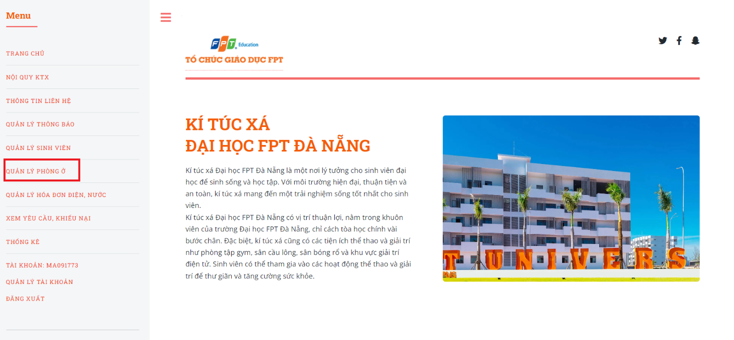

Figure . Step 2 in view room

* Step 3: The system displays all room for management.

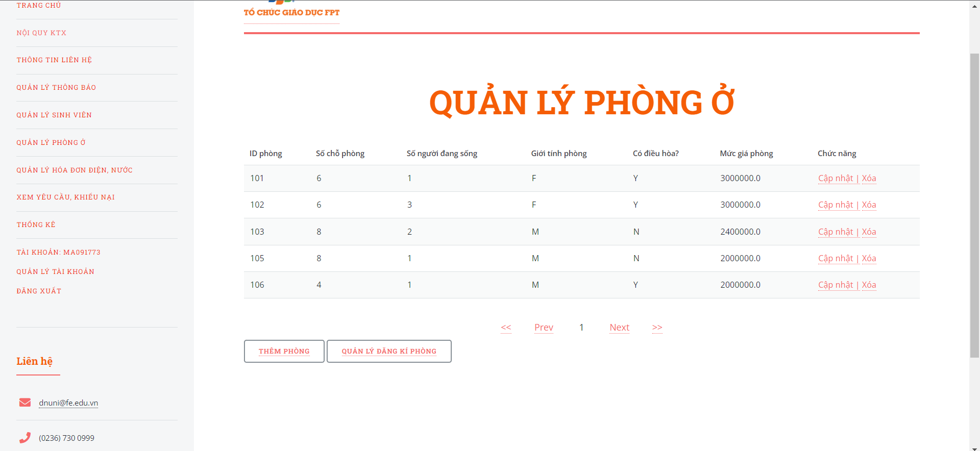

Figure . Step 3 in view room

1. **Create a room.**

This function allows the Admin to create room of the Fdorm website.

* Step 1: Access “QUẢN LÝ PHÒNG Ở” page.
* Step 2: Click on “THÊM PHÒNG” button.

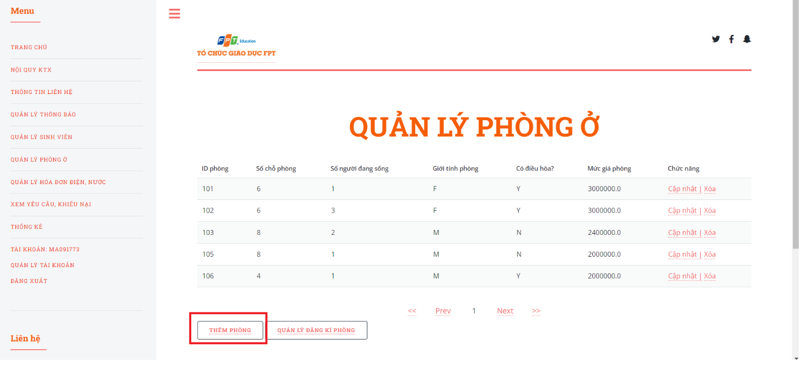

Figure . Step 2 in create room

* Step 3: The system redirects to the create room page, input all the fields

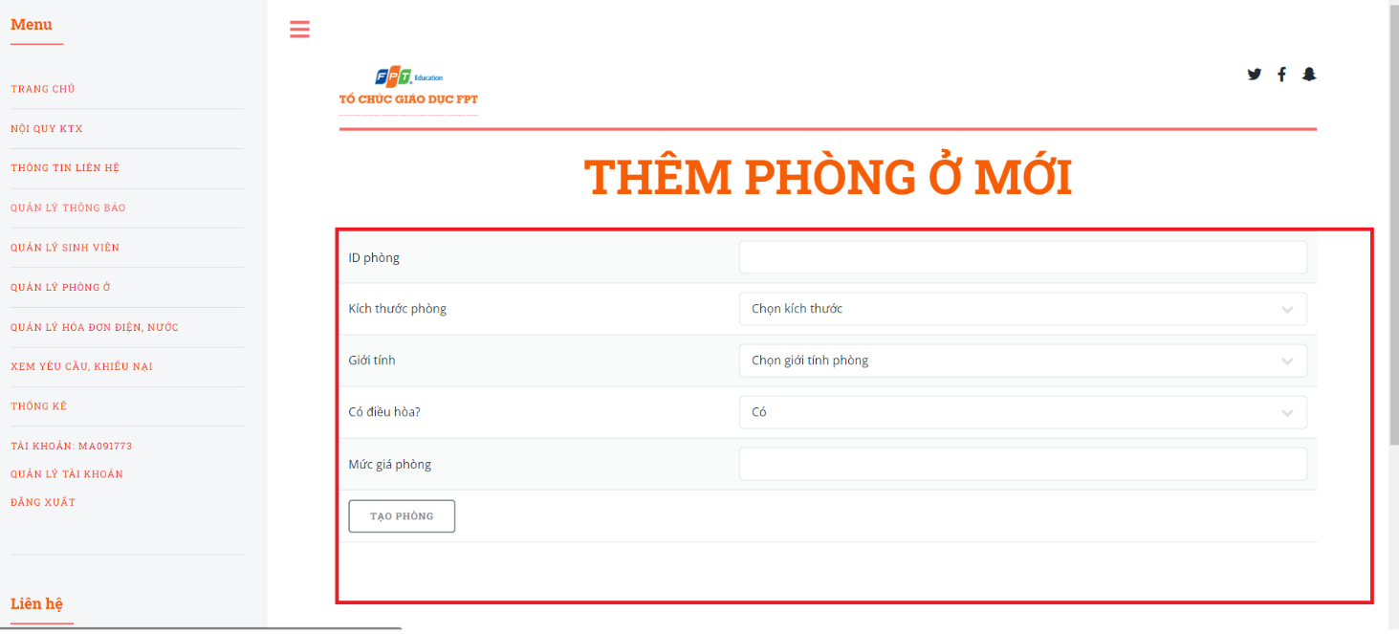

Figure . Step 3 in create room

* Step 4: Click on “TẠO PHÒNG” button

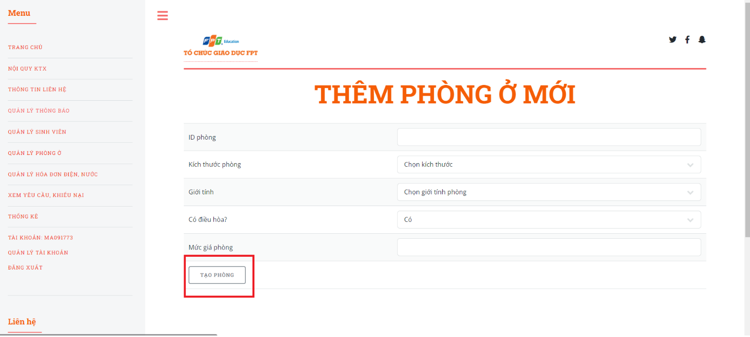

Figure . Step 4 in create room

1. **Update a room.**

This function allows the Admin to update the room of the Fdorm website.

* Step 1: Access “QUẢN LÝ PHÒNG Ở” page.
* Step 2: Click on “Cập nhật”.

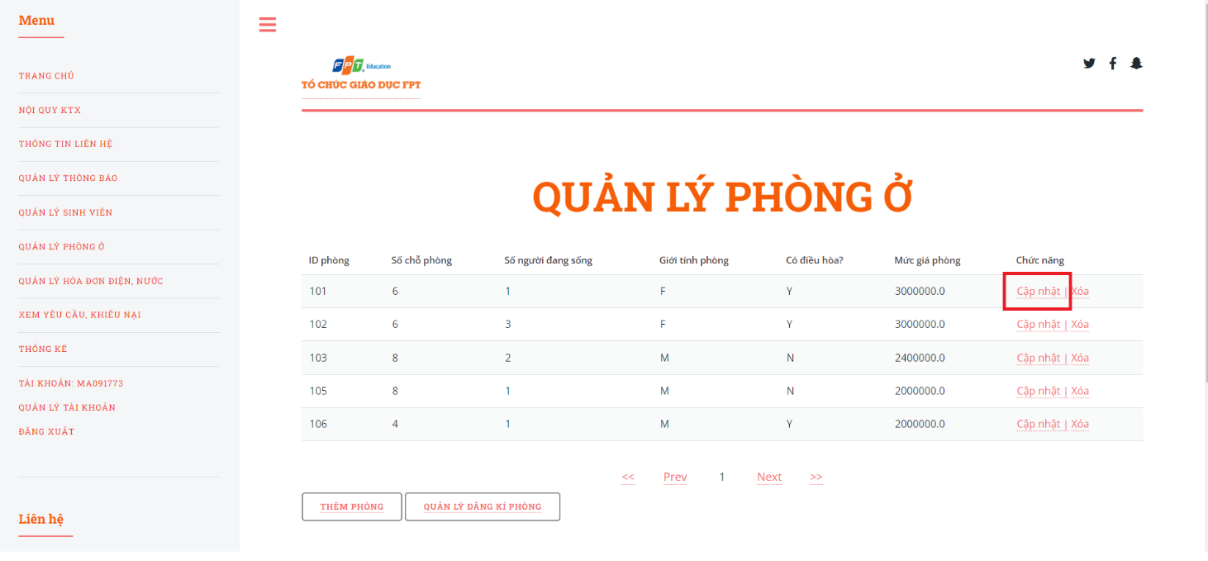

Figure . Step 2 in update room.

* Step 3: The system redirects to the update room page, input the field that the Addmin wants to change

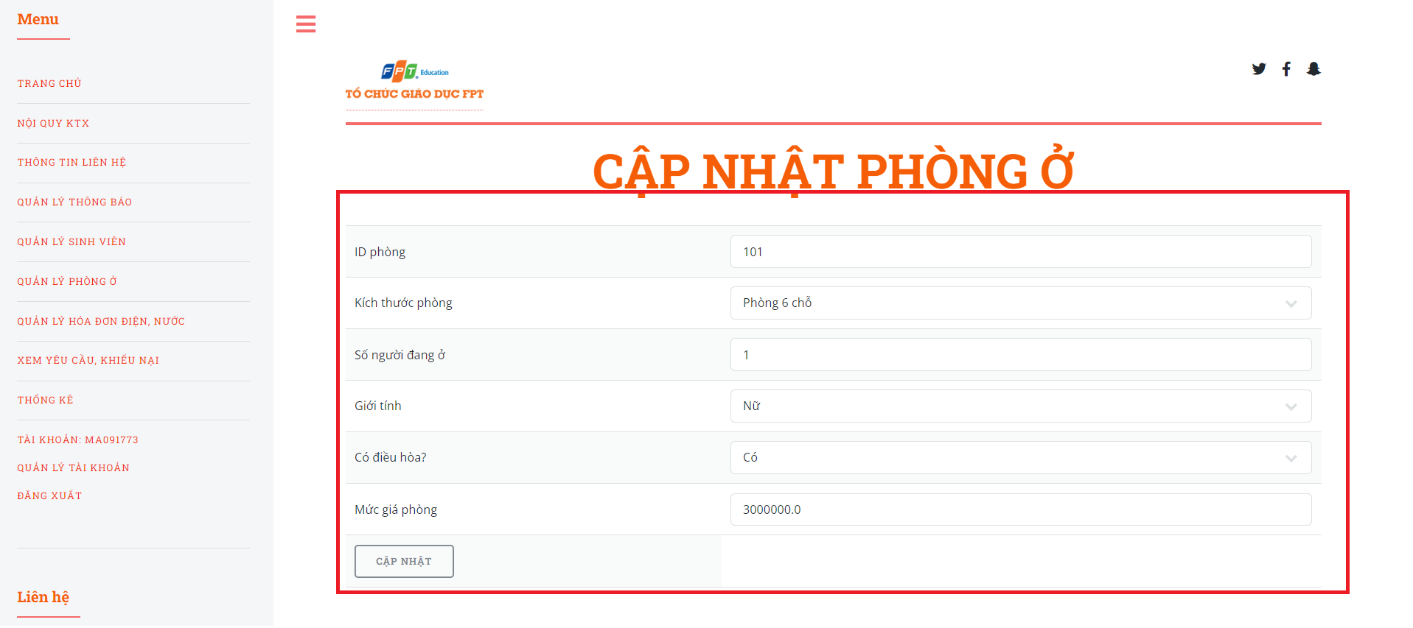

Figure . Step 3 in update room

* Step 4: Click on “CẬP NHẬT” button

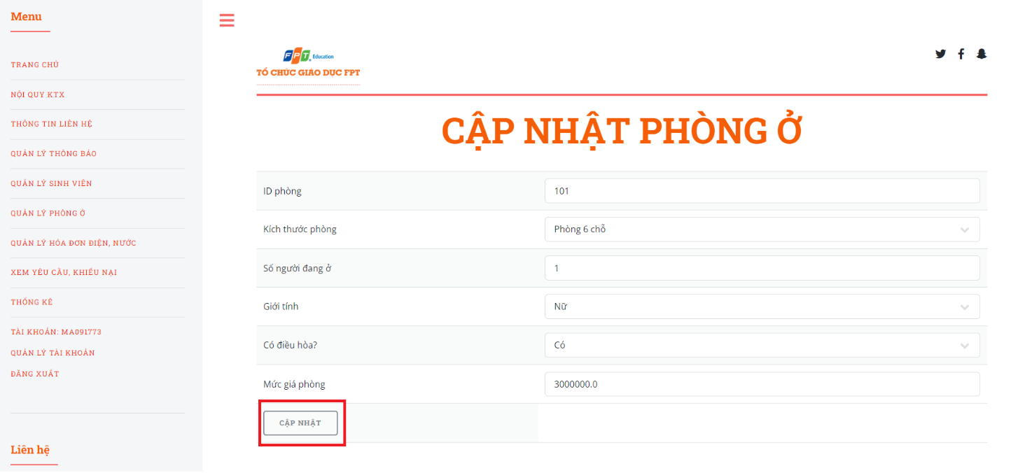

Figure . Step 4 in update room.

1. **Delete a room.**

This function allows the Admin to delete the room of the Fdorm website.

* Step 1: Access “QUẢN LÝ PHỎNG Ở” page.
* Step 2: Click on “Xóa”.

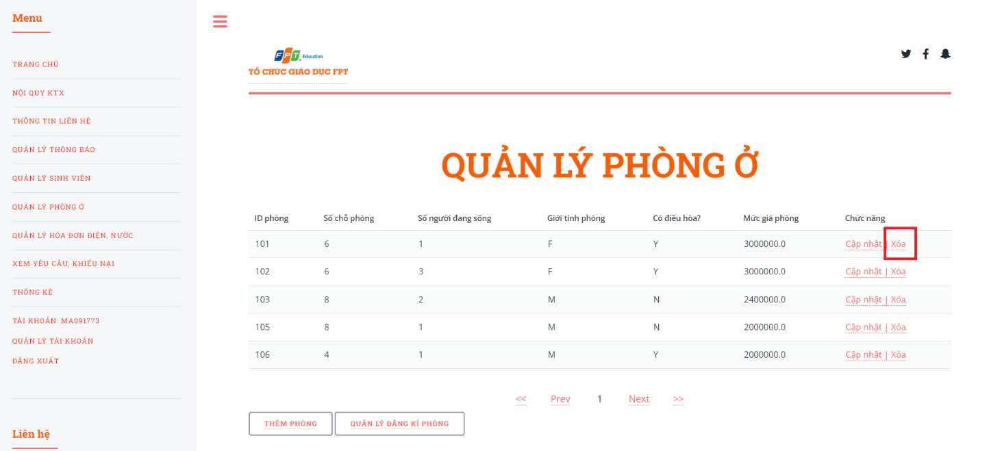

Figure . Step 2 in delete room

* + 1. *View, Create, Update, Delete electricity and water bills.*

1. **View all electricity and water bills to manage.**

This function allows Admin to view all electricity and water bills of the Fdorm website.

* Step 1: Access the Home page with an admin account.
* Step 2: Click on “QUẢN LÝ HÓA ĐƠN ĐIỆN, NƯỚC”

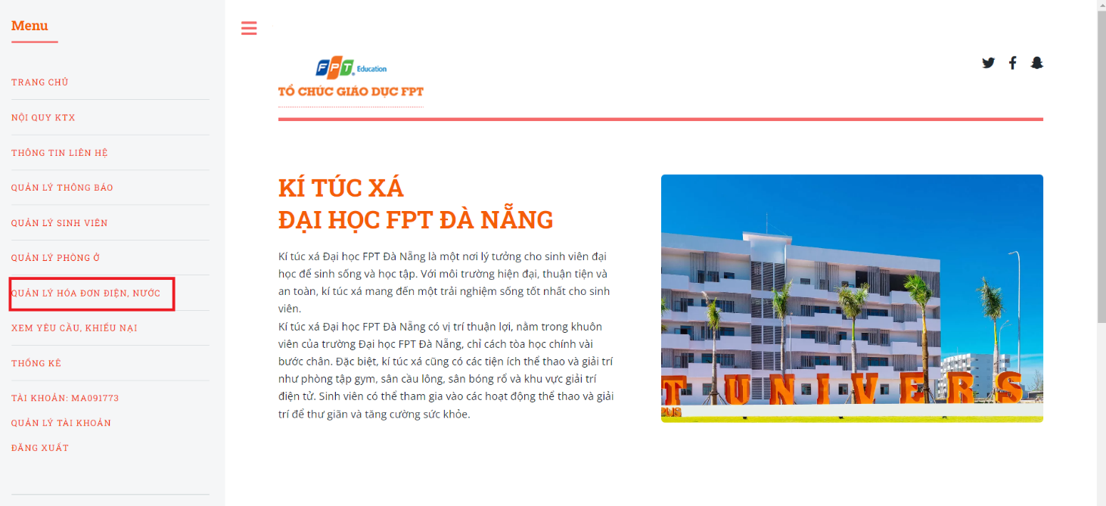

Figure . Step 2 in view all electricity and water bills.

* Step 3: The system displays all electricity and water bills for management.

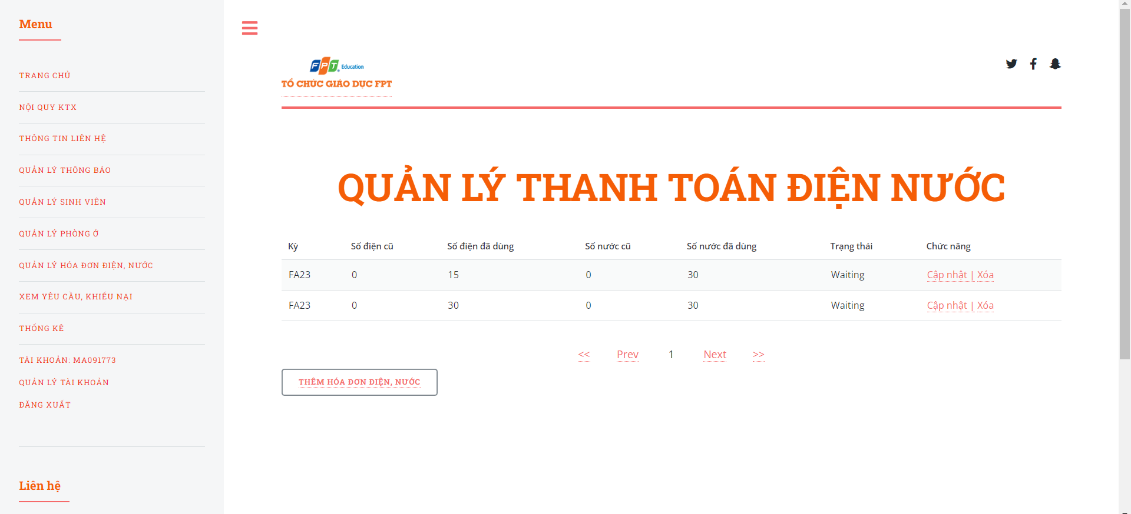

Figure . Step 3 in view all electricity and water bills.

1. **Create an electricity and water bill.**

This function allows the Admin to create a electricity and water bill of the Fdorm website.

* Step 1: Access “QUẢN LÝ HÓA ĐƠN ĐIỆN NƯỚC” page.
* Step 2: Click on “THÊM HÓA ĐƠN ĐIỆN, NƯỚC” button.

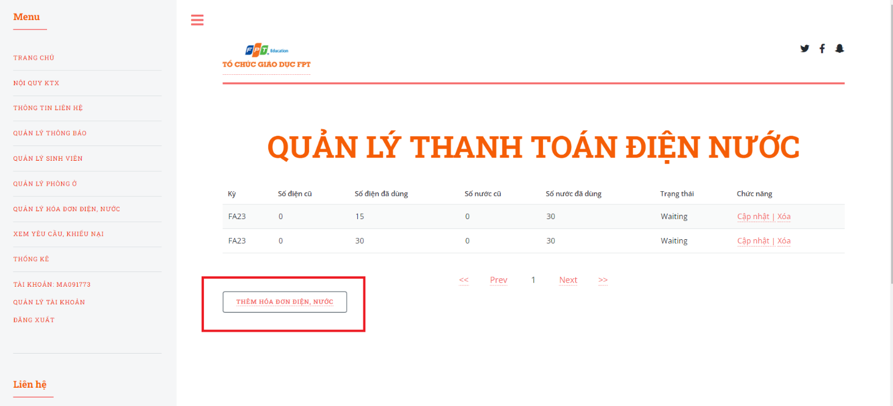

Figure . Step 2 in create an electricity and water bill

* Step 3: The system redirects to the create electricity and water bill page, input all the fields

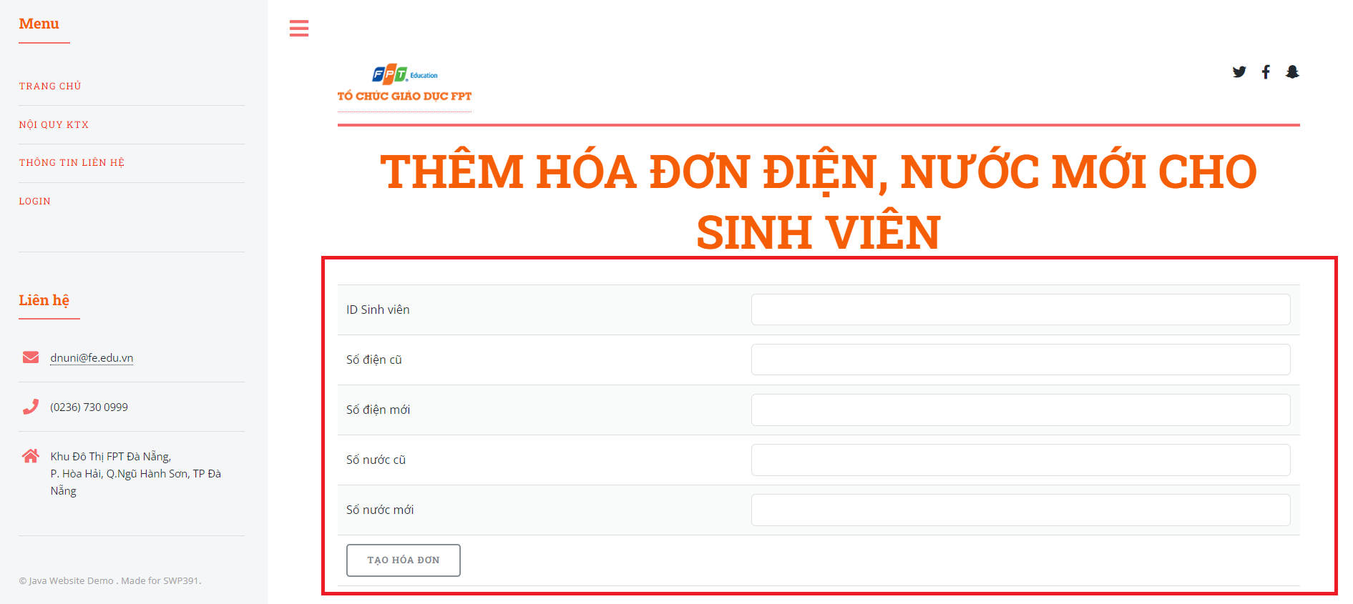

Figure . Step 3 in create an electricity and water bill.

* Step 4: Click on “TẠO HÓA ĐƠN” button.

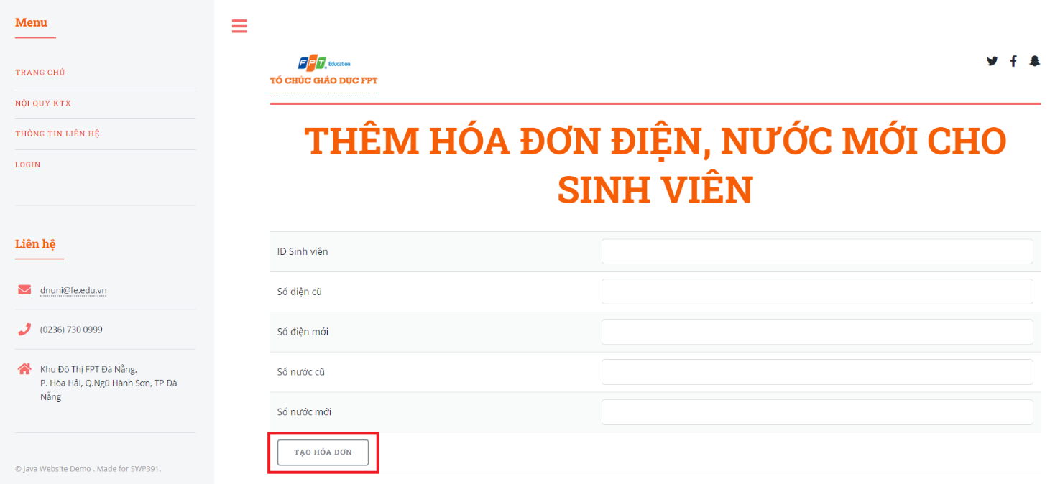

Figure . Step 4 in create an electricity and water bill

1. **Update an electricity and water bill.**

This function allows the Admin to update a electricity and water bill of the Fdorm website.

* Step 1: Access “QUẢN LÝ HÓA ĐƠN ĐIỆN, NƯỚC” page.
* Step 2: Click on “Cập nhật”.

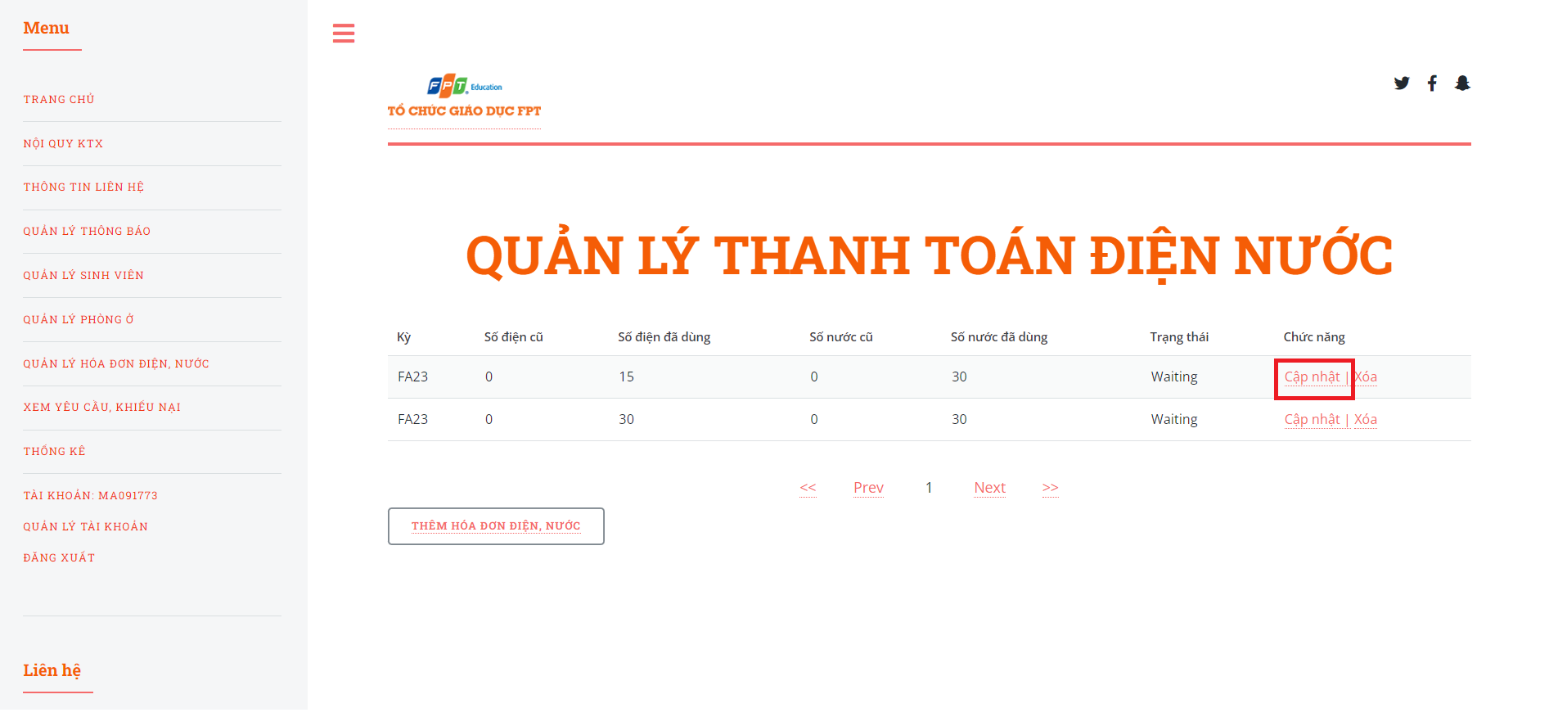

Figure . Step 2 in update an electricity and water bill

* Step 3: The system redirects to the update electricity and water bill page, input the field that the Addmin wants to change.

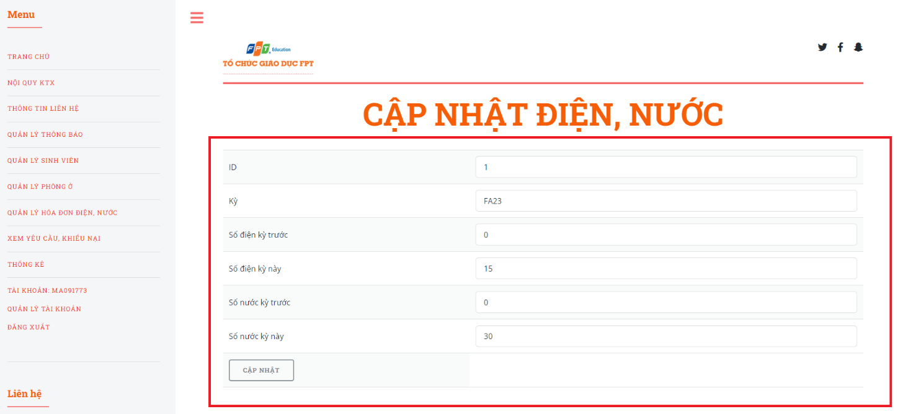

Figure . Step 3 in update an electricity and water bill

* Step 4: Click on “CẬP NHẬT” button

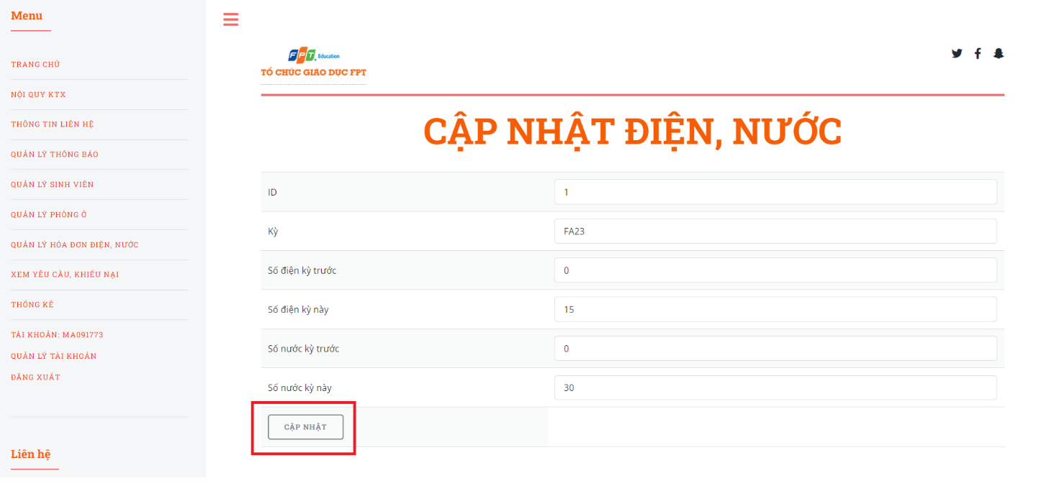

Figure . Step 4 in update an electricity and water bill

1. **Delete an electricity and water bill.**

This function allows the Admin to delete electricity and water bill of the Fdorm website.

* Step 1: Access “QUẢN LÝ HÓA ĐƠN ĐIỆN, NƯỚC” page.
* Step 2: Click on “Xóa”.

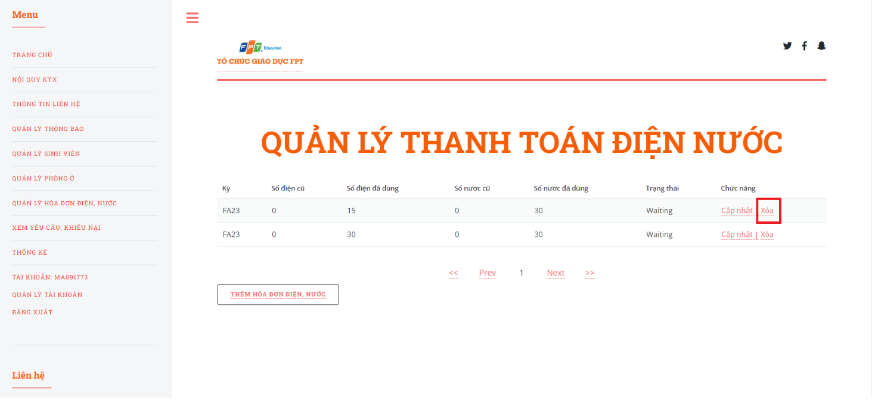

Figure . Step 2 in delete an electricity and water bill

* + 1. *View, Accept, Delete request to change room.*

1. **View request change room**

This is a function that allows Admin to view request change room on Fdorm's website.

* Step 1: Access Homepage with an admin account.
* Step 2: Click on “XEM YÊU CẦU, KHIẾU NẠI”

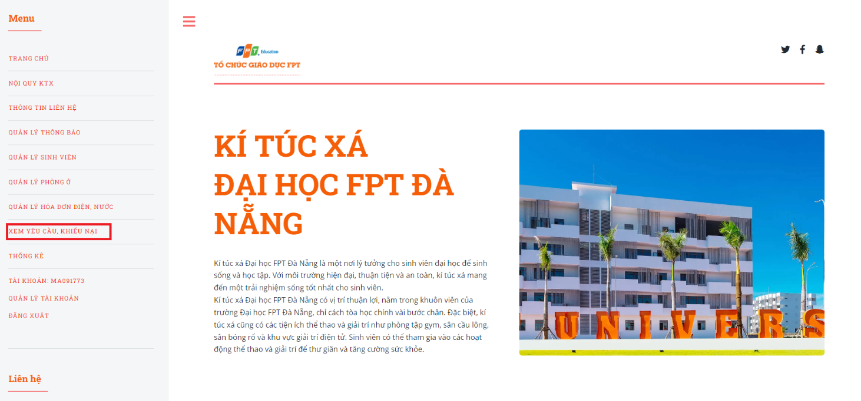

Figure . Step 2 in view change room request

* Step 3: Select request type “Đổi phòng” and lick on “CHỌN” button.

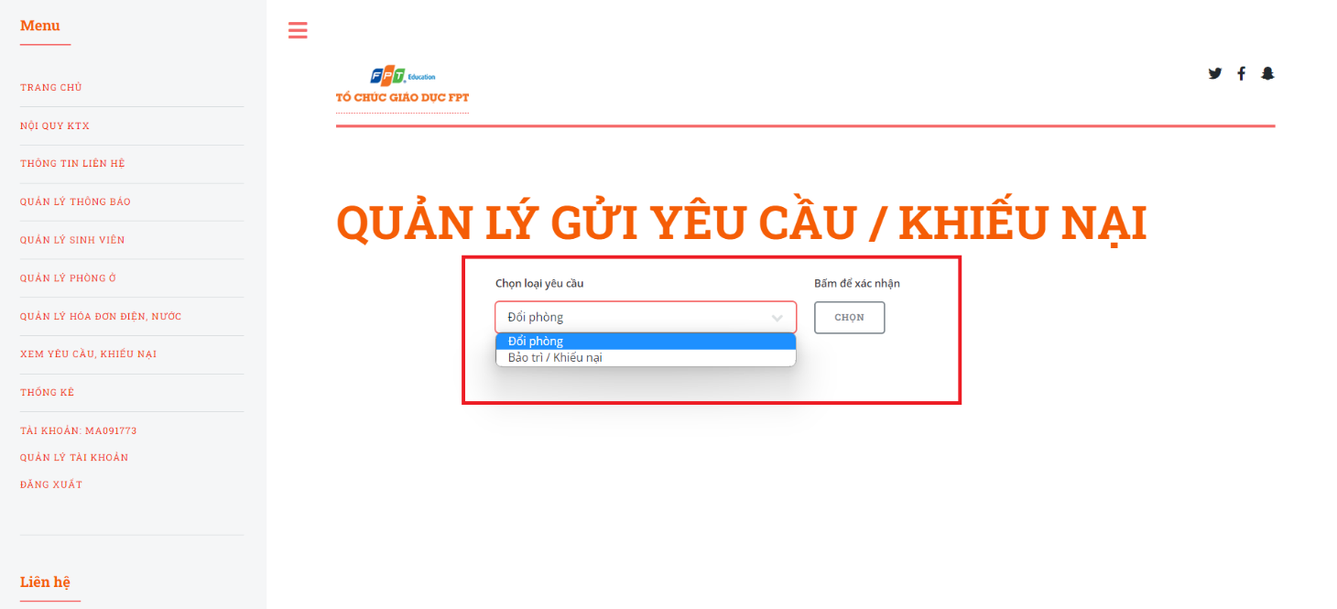

Figure . Step 3 in view change room request

* Step 4: The system displays requests to change rooms.

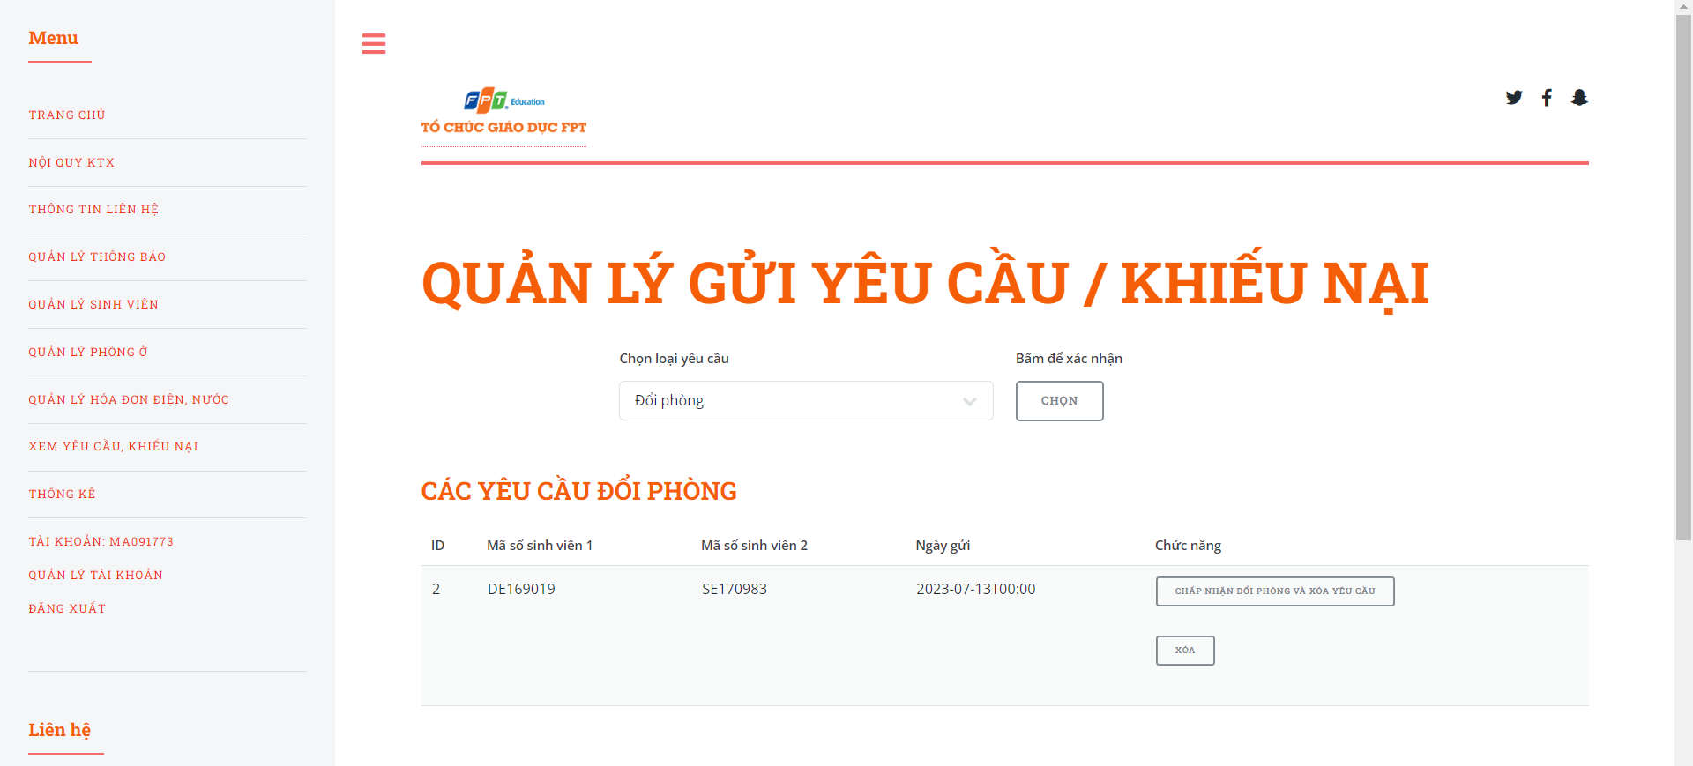

Figure . Step 4 in view change room request

1. **Accept change room**

This function allows the Admin to accept change room request of the Fdorm website.

* Step 1: Access “XEM YÊU CẦU, KHIẾU NẠI” page.
* Step 2: Click on “CHẤP NHẬN YÊU CẦU VÀ XÓA YÊU CẦU”.

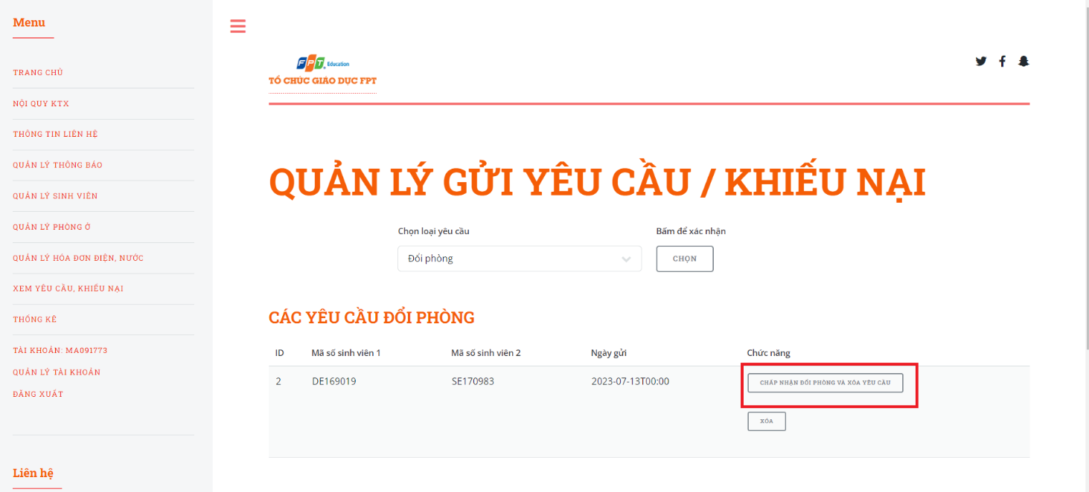

Figure . Step 2 in accept change room request

1. **Delete change room**

This function allows the Admin to delete change room request of the Fdorm website.

* Step 1: Access “XEM YÊU CẦU, KHIẾU NẠI” page.
* Step 2: Click on “XÓA”.

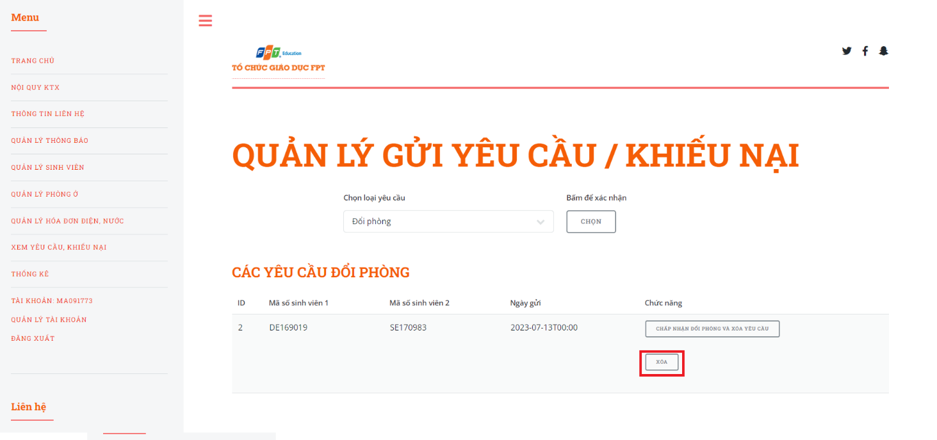

Figure . Step 2 in delete change room request

* + 1. *View statistic.*

This is a function that allows Admin to view statistic on Fdorm's website.

* Step 1: Access Homepage with an admin account.
* Step 2: Click on “THỐNG KÊ”

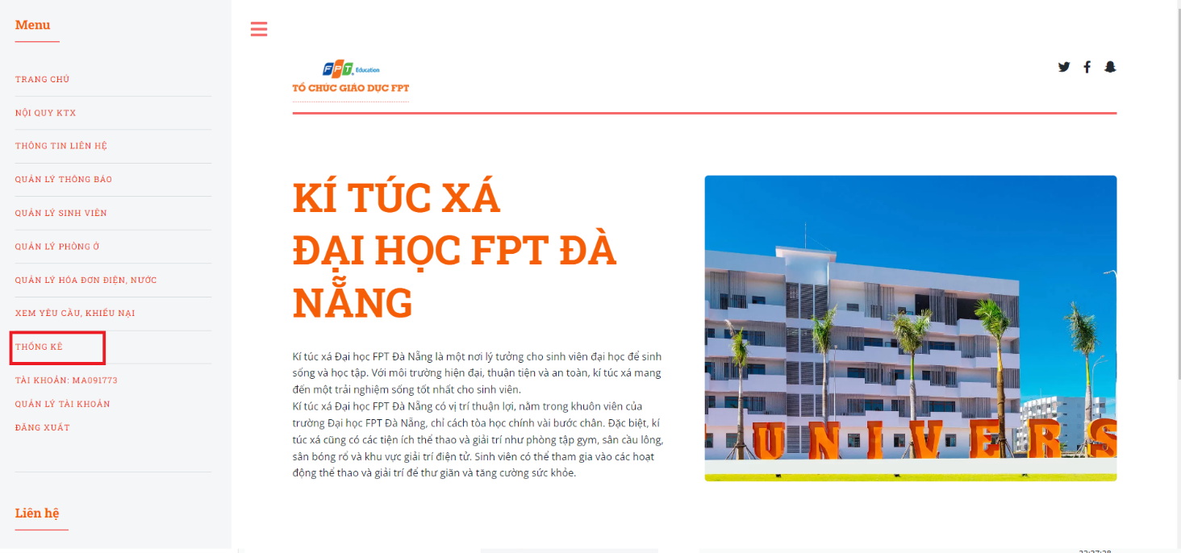

Figure . Step 2 in view statistc

* Step 3: The system displays statistics of the Form system.

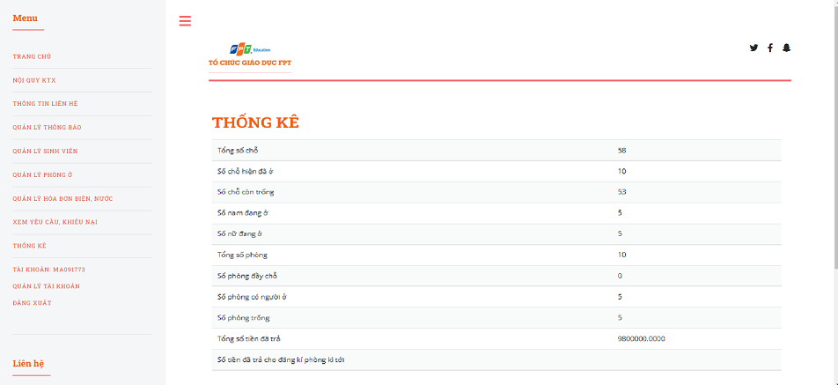

Figure . Step 3 in view statistc